

**EDUCATION-NEWS CONSULT**

**2025/2026 SCHEME OF LERNING**

**0550360658**

[**www.educationnewsconsult.com**](http://www.educationnewsconsult.com)



**Free Online quizzes:** [**www.beceprep.com**](http://www.beceprep.com) **: Downloads and Mock Papers**

**Other Services**

Online Mock Quizzes for BECE and All Classes - [**www.beceprep.com**](http://www.beceprep.com)

BECE Home Mocks

BECE School Mocks

End of term exam questions – hard Copies and Soft Copies

Mock Questions and Answers (Online –MS WORD)

BECE SMARTPICK PREDICTOR

SOFTWARE FOR MONITORING BECE CANDIDATES PERFORMANCE WHICH HELPS PREDICT CATEGORIES FROM WHICH SCHOOLS SHOULD BE CHOSEN

Chat Us on WhatsApp **550360658** for more information

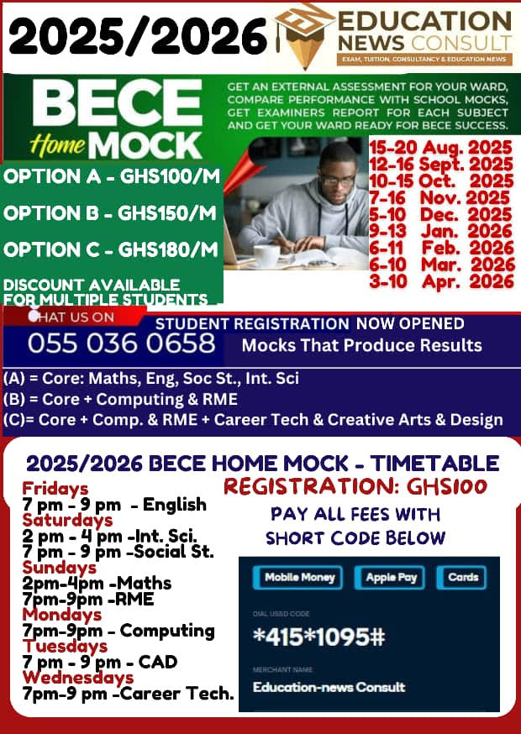

### **Education-News Consult – BECE Prep Mock Schedule (2025/26 Academic Year)**

| **Mock Name** | **Dates** |
| --- | --- |
| Foundation Booster | 23rd – 30th September, 2025 |
| Challenge Booster | 27th October – 3rd November, 2025 |
| Peak Performance Booster | 19th – 23rd January, 2026 |
| Victory Prep Booster | 23rd – 27th February, 2026 |
| Champion’s Booster | 23rd – 27th March, 2026 |
| Final Conquest Booster | 20th – 24th April, 2026 |

### **Mock Options & Charges**

| **Mock Package** | **Price (Per Head)** | **What’s Included** |
| --- | --- | --- |
| Standard Mock Service | GHC 35 | - Question papers (A4 sheets)  - Writing materials  - Expanded marking schemes |
| Pro Mock Service | GHC 50 | - Professional invigilators conduct exams  - Seasoned examiners mark scripts  - Examiner’s report, detailed results & broadsheets within 21 days  - Delivery fee: GHC 50 – GHC 100 (Pick-up available) |

### **Contact Information**

* **Phone:** 0550360658 (WhatsApp and Calls)
* **Location:** Mensah Bar, Dodowa, Accra

**2025/2026 SCHEME OF LEARNING**

**BASIC 2**

**ENGLISH LANGUAGE**

|  |  |  |  |  |  |
| --- | --- | --- | --- | --- | --- |
| **WEEKS** | **STRAND** | **SUB STRANDS** | **CONTENT**  **STANDARD** | **INDICATORS** | **RESOURCES** |
| 1 | Oral Language | Songs | B2.1.1.1 | B2.1.1.1.1. | Word cards, sentence cards, letter cards, handwriting on a manila card and a class library |
| Reading | Phonics | B2.2.2.1 | B2.2.2.1.1 |
| Writing | Penmanship | B2.4.2.1 | B2.4.2.1.1 |
| Writing  Conventions &  Grammar Usage | Using Capitalization | B2.5.1.1 | B2.5.1.1.1 |
| Extensive Reading | Building the love and culture of reading | B2.6.1.1 | B2.6.1.1.1 |
| 2 | Oral Language | Songs | B2.1.1.1 | B2.1.1.1.1. |  |
| Reading | Phonics | B2.2.2.1 | B2.2.2.1.1 |
| Writing | Penmanship | B2.4.2.1 | B2.4.2.1.1 |
| Writing |  |  |  |
|  | Conventions & Grammar Usage | Using Capitalization | B2.5.1.1 | B2.5.1.1.1 |  |
| Extensive Reading | Building the love and culture of reading | B2.6.1.1 | B2.6.1.1.1 |
| 3 | Oral Language | Rhymes | B2.1.2.1 | B2.1.2.1.1 | Word cards, sentence cards, letter cards, handwriting on a manila card and a class library |
| Reading | Phonics | B2.2.2.1 | B2.2.2.1.1 |
| Writing | Writing Letters – Small and Capital | B2.4.3.1 | B2.4.3.1.1 |
| Writing  Conventions &  Grammar Usage | Using Capitalization | B2.5.1.1 | B2.5.1.1.2 |
| Extensive Reading | Building the love and culture of reading | B2.6.1.1 | B2.6.1.1.1 |
| 4 | Oral Language | Story Telling | B2.1.4.1 | B2.1.4.1.1 | Word cards, sentence cards, letter cards, handwriting on a manila card and a class library |
| Reading | Word Families,  Rhyming Endings and  Common Digraphs | B2.2.3.1 | B2.2.3.1.1 |
| Writing | Writing Letters – Small and Capital | B2.4.3.1 | B2.4.3.1.1 |

|  |  |  |  |  |  |
| --- | --- | --- | --- | --- | --- |
|  | Writing |  |  |  |  |
|  | Conventions & Grammar Usage | Using Punctuation | B2.5.2.1 | B2.5.2.1.1 |  |
| Extensive Reading | Building the love and culture of reading | B2.6.1.1 | B2.6.1.1.1 |
| 5 | Oral Language | Dramatization and Role-Play | B2.1.5.1 | B2.1.5.1.1 | Word cards, sentence cards, letter cards, handwriting on a manila card and a class library |
| Reading | Word Families,  Rhyming Endings and  Common Digraphs | B2.2.3.1 | B2.2.3.1.2 |
| Writing | Labelling Items | B2.4.4.1 | B2.4.4.1.1 |
| Writing |  |  |  |
|  | Conventions & Grammar Usage | Using Action Words | B2.5.4.1 | B2.5.4.1.1 |  |
| Extensive Reading | Building the love and culture of reading | B2.6.1.1 | B2.6.1.1.1 |
| 6 | Oral Language | Conversation | B2.1.6.1 | B2.1.6.1.1 | Word cards, sentence cards, letter cards, handwriting on a manila card and a class library |
| Reading | Vocabulary | B2.2.6.1 | B2.2.6.1.1 |
| Writing | Writing Simple  Words and Sentences | B2.4.5.1 | B2.4.5.1.1 |
| Writing  Conventions &  Grammar Usage | Using Qualifying  Words – Adjectives | B2.5.5.1. | B2.5.5.1.1. |
| Extensive Reading | Building the love and culture of reading | B2.6.1.1 | B2.6.1.1.1 |
| 7 | Oral Language | Conversation | B2.1.6.1 | B2.1.6.1.2 | Word cards, sentence cards, letter cards, handwriting on a manila card and a class library |
| Reading | Vocabulary | B2.2.6.1 | B2.2.6.1.1 |
| Writing | Writing Simple  Words and Sentences | B2.4.5.1 | B2.4.5.1.1 |

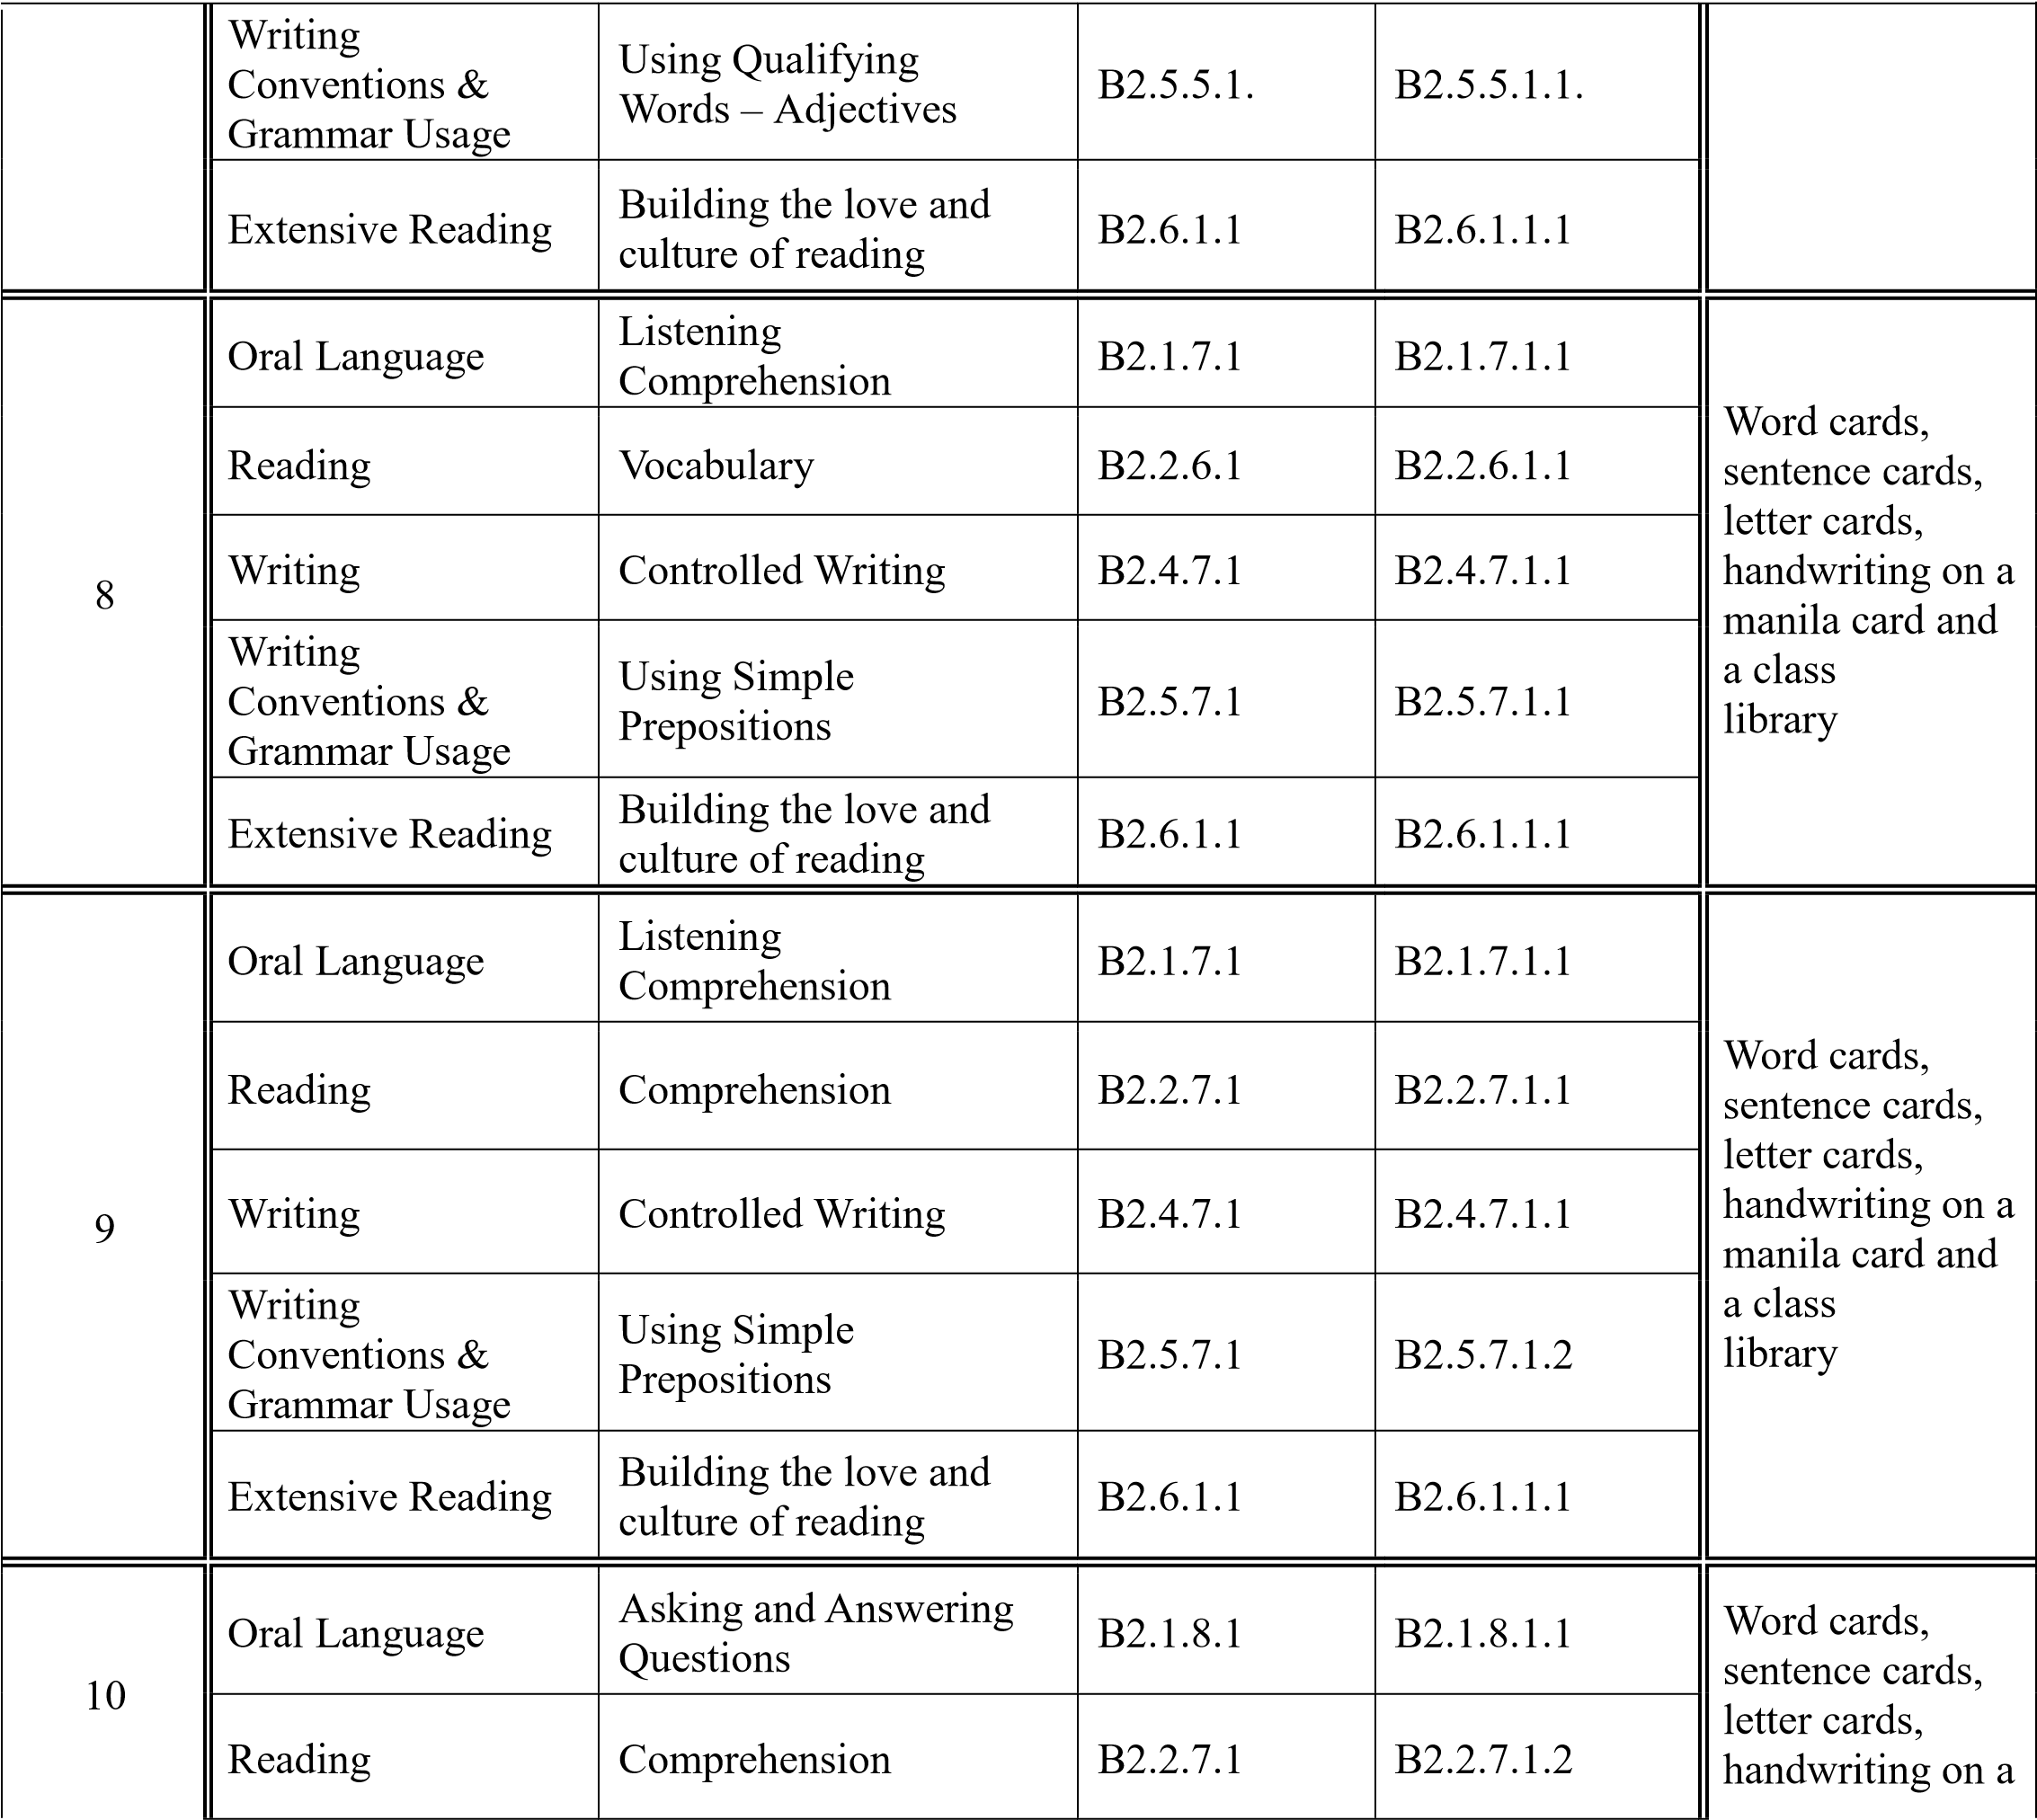

|  |  |  |  |  |  |
| --- | --- | --- | --- | --- | --- |
|  | Writing | Guided Composition | B2.4.8.1 | B2.4.8.1.1 | manila card and a class  library |
| Writing  Conventions &  Grammar Usage | Using Simple and  Compound Sentences | B2.5.9.1 | B2.5.9.1.1 |
|  | Extensive Reading | Building the love and culture of reading | B2.6.1.1 | B2.6.1.1.1 |  |
| 11 | Oral Language | Giving and Responding to Commands | B2.1.9.1 | B2.1.9.1.1 | Word cards, sentence cards, letter cards, handwriting on a manila card and a class  library |
| Reading | Comprehension | B2.2.7.1 | B2.2.7.1.3 |
| Writing | Narrative Writing | B2.4.10.1 | B2.4.10.1.1 |
| Writing  Conventions &  Grammar Usage | Using Simple and  Compound Sentences | B2.5.9.1 | B2.5.9.1.2 |
| Extensive Reading | Building the love and culture of reading | B2.6.1.1 | B2.6.1.1.1 |
| 12 | Oral Language | Giving and Responding to Commands | B2.1.9.1 | B2.1.9.1.1 | Word cards, sentence cards,  letter cards, handwriting on a manila card and a class  library |
| Reading | Fluency | B2.2.9.1 | B2.2.9.1.1 |
| Writing | Descriptive Writing | B2.4.12.1 | B2.4.12.1.1 |
| Writing  Conventions &  Grammar Usage | Spelling | B2.5.10.1 | B2.5.10.1.1 |
| Extensive Reading | Building the love and culture of reading | B2.6.1.1 | B2.6.1.1.1 |
| 13 | Oral Language | Presentation | B2.1.10.1 | B2.1.10.1.1 | Word cards, sentence cards,  letter cards, handwriting on a manila card and a class  library |
| Reading | Fluency | B2.2.9.1 | B2.2.9.1.1 |
| Writing | Descriptive Writing | B2.4.12.1. | B2.4.12.1.1 |
| Writing  Conventions &  Grammar Usage | Spelling | B2.5.10.1 | B2.5.10.1.1 |
| Extensive Reading | Building the love and culture of reading | B2.6.1.1 | B2.6.1.1.1 |
| **14** |  | **REVISION** |  |  |
| **15** |  | **ASSESSMENT** |  |  |
| **16** |  | **VACATION** |  |  |

**MATHEMATICS**

|  |  |  |  |  |  |
| --- | --- | --- | --- | --- | --- |
| **WEEKS** | **STRAND** | **SUB**  **STRANDS** | **CONTENT**  **STANDARD** | **INDICATORS** | **RESOURCES** |
| **1** | Number | Counting,  Representation & Cardinality | B2.1.1.1 | B2.1.1.1.1 | Counters patterns made from manila  cards |
| **2** | Number | Counting,  Representation & Cardinality | B2.1.1.1 | B2.1.1.1.1 |
| **3** | Number | Counting,  Representation & Cardinality | B2.1.1.1 | B2.1.1.1.1 |
| **4** | Number | Counting,  Representation & Cardinality | B2.1.1.1 | B2.1.1.1.2 | Counters patterns made from manila  cards |
| **5** | Number | Number  Operations | B2.1.2.1 | B2.1.2.1.1 |
| **6** | Number | Number  Operations | B2.1.2.1 | B2.1.2.1.1 | Counters patterns made from manila  cards |
| **7** | Number | Number  Operations | B2.1.2.2 | B2.1.2.2.1 |
| **8** | Number | Fractions | B2.1.3.1 | B2.1.3.1.1 | Paper strips, cut out cards |
| **9** | Number | Fractions | B2.1.3.1 | B2.1.3.1.2 | Paper strips, cut out cards |
| **10** | Number | Fractions | B2.1.3.1 | B2.1.3.1.3 | Paper strips, cut out cards |
| **11** | Number | Money | B2.1.4.1 | B2.1.4.1.1 | Ghana  Cedi(notes & coins) |
| **12** | Algebra | Patterns And Relationship | B2.2.1.1 | B2.2.1.1.1 | Counters patterns made from manila cards |
| **13** | Algebra | Patterns And Relationship | B2.2.1.1 | B2.2.1.1.2 |
| **14** |  | **REVISION** |  |  |
| **15** |  | **ASSESSMENT** |  |  |
| **16** |  | **VACATION** |  |  |

**SCIENCE**

|  |  |  |  |  |  |
| --- | --- | --- | --- | --- | --- |
| **WEEKS** | **STRAND** | **SUB STRANDS** | **CONTENT**  **STANDARD** | **INDICATORS** | **RESOURCES** |
| **1** | Diversity of Matter | Living And Non Living Things | B2.1.1.1 | B2.1.1.1.1 | Pictures of Plants and animals in the environment , plastics videos paper, metal woods  pencil |
| **2** | Diversity of Matter | Living And Non Living Things | B2.1.1.1 | B2.1.1.1.1 |
| **3** | Diversity of Matter | Living And Non Living Things | B2.1.1.1 | B2.1.1.1.1 |
| **4** | Diversity of Matter | Living And Non Living Things | B2.1.1.2 | B2.1.1.2.1 | Pictures of Plants and animals in the environment , plastics videos |
| **5** | Diversity of Matter | Living And Non Living Things | B2.1.1.2 | B2.1.1.2.2 | paper, metal woods  pencil |
| **6** | Diversity of Matter | Materials | B2.1.2.1 | B2.1.2.1.1 | Metals, woods plastics soil stones paper pencil crayons  balloons water sand salt sugar |
| **7** | Diversity of Matter | Materials | B2.1.2.2 | B2.1.2.2.1 |
| **8** | Diversity of Matter | Materials | B2.1.2.3 | B2.1.2.3.1 | Metals, woods plastics soil stones paper pencil crayons  balloons water sand salt sugar |
| **9** | Diversity of Matter | Materials | B2.1.2.3 | B2.1.2.3.1 |
| **10** | Cycles | Earth Science | B2.2.1.1 | B2.2.1.1.1 | Torch candle matchstick lantern paper pencil pictures of well river stream water |
| **11** | Cycles | Earth Science | B2.2.1.2 | B2.2.1.2.1 |
| **12** | Cycles | Earth Science | B2.2.1.4. | B2.2.1.4.1 | Torch candle matchstick lantern paper pencil pictures of well river stream water |
| **13** | Cycles | Earth Science | B2.2.1.4 | B2.2.1.4.2 |
| **14** |  | **REVISION** |
| **15** |  | **ASSESSMENT** |
| **16** |  | **VACATION** |

**OUR WORLD OUR PEOPLE**

|  |  |  |  |  |  |
| --- | --- | --- | --- | --- | --- |
| **WEEKS** | **STRAND** | **SUB STRANDS** | **CONTENT**  **STANDARD** | **INDICATORS** | **RESOURCES** |
| **1** | All About Us | Nature of God | B2.1.1.1 | B2.1.1.1.1 | Pictures,  Charts,  Video Clips |
| **2** | All About Us | Nature of God | B2.1.1.1 | B2.1.1.1.1 |  |
| **3** | All About Us | Nature of God | B2.1.1.1 | B2.1.1.1.2 | Pictures,  Charts,  Video Clips |
| **4** | All About Us | My self | B2.1.2.1 | B2.1.2.1.1 | Pictures,  Charts,  Video Clips |
| **5** | All About Us | Myself | B2.1.2.1 | B2.1.2.1.2 |
| **6** | All About Us | My Family & the community | B2.1.3.1 | B2.1.3.1.1 | Pictures,  Charts,  Video Clips |
| **7** | All About Us | My Family & the community | B2.1.3.1 | B2.1.3.1.2 | Pictures,  Charts,  Video Clips |
| **8** | All About Us | Home & School | B2.1.4.1 | B2.1.4.1.1 | Pictures,  Charts,  Video Clips |
| **9** | All About Us | Home & School | B2.1.4.1 | B2.1.4.1.2 |
| **10** | All Around Us | The Environment  and the Weather | B2.2.1.1 | B2.2.1.1.1 | Pictures,  Charts,  Video Clips |
| **11** | All Around Us | The Environment  and the Weather | B2.2.1.1 | B2.2.1.1.2 |
| **12** | All Around Us | Plants and Animals | B2.2.2.1 | B2.2.2.1.1 | Pictures,  Charts,  Video Clips |
| **13** | All Around Us | Plants and Animals | B2.2.2.1 | B2.2.2.1.2 |
| **14** |  | **REVISION** |  |  |
| **15** |  | **ASSESSMENT** |  |  |
| **16** |  | **VACATION** |  |  |

**RELIGIOUS & MORAL EDUCATION**

|  |  |  |  |  |  |
| --- | --- | --- | --- | --- | --- |
| **WEEKS** | **STRAND** | **SUB STRANDS** | **CONTENT STANDARD** | **INDICATORS** | **RESOURCES** |
| **1** | God’s creation and Attributes | God the Creator | B2.1.1.1 | B2.1.1.1.1 | Wall charts, wall words, posters, video clip, etc. |
| **2** | God’s creation and Attributes | God the Creator | B2.1.1.1 | B2.1.1.1.1 |
| **3** | God’s creation and Attributes | God the Creator | B2.1.1.1 | B2.1.1.1.1 |
| **4** | God’s creation and Attributes | God the Creator | B2.1.1.1 | B2.1.1.1.1 | Wall charts, wall words, posters, video clip, etc. |
| **5** | God’s creation and Attributes | God the Creator | B2.1.1.1 | B2.1.1.1.1 |
| **6** | God’s creation and Attributes | The Environment | B2.1.2.1 | B2.1.2.1.1: | Wall charts, wall words, posters, video clip, etc. |
| **7** | God’s creation and Attributes | The Environment | B2.1.2.1 | B2.1.2.1.1: |
| **8** | God’s creation and Attributes | The Environment | B2.1.2.1 | B2. 1.2.1.2: | Wall charts, wall words, posters, video clip, etc. |
| **9** | God’s creation and Attributes | The Environment | B2.1.2.1 | B2. 1.2.1.2: |
| **10** | God’s creation and Attributes | Purpose of God’s Creation | B2.1.3.1 | B2.1.3.1.1 | Wall charts, wall words, posters, video clip, etc. |
| **11** | God’s creation and Attributes | Purpose of God’s Creation | B2.1.3.1. | B2.1.3.1.1 |
| **12** | God’s creation and Attributes | Purpose of God’s Creation | B2.1.3.1. | B2.1.3.1.1 | Wall charts, wall words, posters, video clip, etc. |
| **13** | God’s creation and Attributes | Purpose of God’s Creation | B2.1.3.1. | B2.1.3.1.1 |
| **14** |  | **REVISION** |  |  |
| **15** |  | **ASSESSMENT** |  |  |
| **16** |  | **VACATION** |  |  |

**HISTORY**

|  |  |  |  |  |  |
| --- | --- | --- | --- | --- | --- |
| **WEEKS** | **STRAND** | **SUB STRANDS** | **CONTENT STANDARD** | **INDICATORS** | **RESOURCES** |
| **1** | My Country Ghana | The People of Ghana | B2.2.1.1 | B2.2.1.1.1 | A map of Ghana indicating the various ethnic groups. |
| **2** | My Country Ghana | The People of Ghana | B2.2.1.1 | B2.2.1.1.1 |
| **3** | My Country Ghana | The People of Ghana | B2.2.1.1 | B2.2.1.1.1 |
| **4** | My Country Ghana | The People of Ghana | B2.2.1.1 | B2.2.1.1.1 |
| **5** | My Country Ghana | The People of Ghana | B2.2.1.1 | B2.2.1.1.1 | A map of Ghana tracing the migration route of the ethnic groups. |
| **6** | My Country Ghana | The People of Ghana | B2.2.1.1 | B2.2.1.1.1 |
| **7** | My Country Ghana | The People of Ghana | B2.2.1.1 | B2.2.1.1.1 |
| **8** | My Country Ghana | The People of Ghana | B2.2.1.1 | B2.2.1.1.1 | A poster showing a timeline of the periods each group arrived in  Ghana |
| **9** | My Country Ghana | The People of Ghana | B2.2.1.1 | B2.2.1.1.1 |
| **10** | My Country Ghana | The People of Ghana | B2.2.1.1 | B2.2.1.1.1 | A map of Ghana tracing the migration route of the ethnic groups. |
| **11** | My Country Ghana | The People of Ghana | B2.2.1.1 | B2.2.1.1.1 |
| **12** | My Country Ghana | Major Historical locations | B2.2.4.1 | B2.2.4.1.1 | A map of ghana  showing major historical locations |
| **13** | My Country Ghana | Major Historical locations | B2.2.4.1 | B2.2.4.1.1 |
| **14** |  | **REVISION** |  |  |
| **15** |  | **ASSESSMENT** |  |  |
| **16** |  | **VACATION** |  |  |

**CREATIVE ARTS**

|  |  |  |  |  |  |
| --- | --- | --- | --- | --- | --- |
| **WEEKS** | **STRAND** | **SUB STRANDS** | **CONTENT**  **STANDARD** | **INDICATORS** | **RESOURCES** |
| **1** | Visual Arts | Thinking and  Exploring Ideas  (Visual Arts) | CSE 1 | B2. 1.1.1.1 | Photos, videos, art paper, colors and traditional art tools, other materials available in the community |
| **2** | Visual Arts | Thinking and  Exploring Ideas  (Visual Arts) | CSE 1 | B2. 1.1.1.1 |
| **3** | Performing Arts | Thinking and  Exploring Ideas  (Performing Arts) | CSE 1 | B2. 2.1.1.1 |
| **4** | Visual Arts | Planning, Making and Composing  (Visual Arts) | CSE 2&3 | B2.1.2.2.1  B2.1.2.3.1 | Photos, videos, art paper, colors and traditional art |
| **5** | Performing Arts | Planning, Making and Composing  (Performing Arts) | CSE 2&3 | B2.2.2.2.1  B2.2.2.3.1 | tools, other materials available in the community |
| **6** | Visual Arts | Displaying and Sharing  (Visual Arts) | CSE 4&5 | B2.1.3.4.1  B2.1.3.5.1 | Photos, videos, art paper, colors and traditional art tools, other materials available in the community |
| **7** | Performing Arts | Displaying and Sharing  (Performing Arts) | CSE 4&5 | B2.2.3.4.1  B2.2.3.5.1 |
| **8** | Visual Arts | Appreciating and Appraising  (Visual Arts) | CSE 6&7 | B2.1.4.6.1  B2.1.4.7.1 | Photos, videos, art paper, colors and traditional art tools, other materials available in the community |
| **9** | Performing Arts | Appreciating and Appraising  (Performing Arts) | CSE 6&7 | B2.2.4.6.1  B2.2.4.7.1 |
| **10** | Visual Arts  &  Performing  Arts | Thinking and  Exploring Ideas  School based project  (Visual Arts & performing Arts) | CSE 1 | B2.1.1.1  B2.2.1.1 | Photos, videos, art paper, colors and traditional art tools, other materials available in the community |
| **11** | Visual Arts  &  Performing  Arts | Planning, Making and Composing  School based project  (Visual Arts & Performing | CSE 2&3 |  | Photos, videos, art paper, colors and traditional art tools, other  materials available in the community |
| **12** | Visual Arts  &  Performing  Arts | Displaying and Sharing  School based project  (Visual Arts &  Performing Arts) | CSE 4&5 |  | Photos, videos, art paper, colors and traditional art tools, other materials available in the community |
| **13** | Visual Arts  &  Performing  Arts | Appreciating and Appraising  School based project  (Visual Arts &  Performing Arts) | CSE 6&7 |  | Photos, videos, art paper, colors and traditional art tools, other materials available in the community |
| **14** |  | **REVISION** |  |  |  |
| **15** |  | **ASSESSMENT** |  |  |  |
| **16** |  | **VACATION** |  |  |  |

**GHANAIAN LANGUAGE**

|  |  |  |  |  |  |
| --- | --- | --- | --- | --- | --- |
| **WEEKS** | **STRAND** | **SUB STRANDS** | **CONTENT**  **STANDARD** | **INDICATORS** | **RESOURCES** |
| **1** | Listening and Speaking | Songs | B2.1.1.1 | B2.1.1.1.1-3 | Word cards, sentence cards, letter cards, handwriting on a manila card |
| **2** | Listening and Speaking | Songs | B2.1.1.1 | B2.1.1.1.1-3 |
| **3** | Listening and Speaking | Rhymes | B2.1.2.1 | B2.1.2.1.1-2 |
| **4** | Listening and Speaking | Listening & Story Telling | B2.1.4.1 | B2.1.4.1.1-3 |
| **5** | Reading | Phonological &  Phonemic  Awareness | B2.2.3.1 | B2.2.3.1.1 | Word cards, sentence cards, letter cards, handwriting on a manila card |
| **6** | Reading | Phonics: letter & sound knowledge | B2.2.4.1 | B2.2.4.1.1-3 |
| **7** | Reading | Phonics: letter & sound knowledge | B2.2.4.2 | B2.2.4.2.1-4 |
| **8** | Writing | Penmanship & Handwriting | B2.3.1.1 | B2.3.1.1.1-2 | Word cards, sentence cards, letter cards, |
| **9** | Writing | Penmanship & Handwriting | B2.3.1.1 | B2.3.1.1.3-4 |
| **10** | Writing  Conventions | Integrating  Grammar in  Written Language  (Capitalization) | B2.5.1.1 | B2.5.1.1.1-3 | Word cards, sentence cards, letter cards, handwriting on a manila card |
| **11** | Writing  Conventions | Integrating  Grammar in  Written Language  (Punctuation) | B2.5.3.1 | B2.5.3.1.1 |
| **12** | Extensive Reading | Building the love and culture of reading in learners | B2.6.1.1 | B2.6.1.1.1 | Word cards, sentence cards, letter cards and a class library |
| **13** | Extensive Reading | Reading Aloud | B2.6.2.1 | B2.6.2.1.1 |
| **14** | **REVISION** |  |  |  |
| **15** | **EXAMINATION** |  |  |  |
| **16** | **VACATION** |  |  |  |

# COMPUTING

|  |  |  |  |  |  |
| --- | --- | --- | --- | --- | --- |
| **WEEK** | **STRAND** | **SUB- STRANDS** | **CONTENT STANDARD** | **INDICATORS** | **RESOURCES** |
| **1** | Introduction to computing | Generation of computers and parts of a computer and other gadgets | B2.5.2.1 | B2.5.2.1.1 | Laptop, projector |
| **2** | Introduction to computing | Generation of computers and parts of a computer and other gadgets | B2.5.2.1 | B2.5.2.1.1 |  |
| **3** | Introduction to computing | Generation of computers and parts of a computer and other gadgets | B2.5.2.1 | B2.5.2.1.1 | Laptop, projector |
| **4** | Introduction to computing | Generation of computers and parts of a computer and other gadgets | B2.5.2.1 | B2.5.2.1.1 | Laptop, projector |
| **5** | Introduction to computing | Generation of computers and parts of a computer and other gadgets | B2.5.2.1 | B2.5.2.1.1 | Laptop, projector |
| **6** | Introduction to computing | Generation of computers and parts of a computer and other gadgets | B2.5.2.1 | B2.5.2.1.1 | Laptop, projector |
| **7** | Introduction to computing | Generation of computers and parts of a computer and other gadgets | B2.5.2.1 | B2.5.2.1.1 | Laptop, projector |
| **8** | Introduction to computing | Generation of computers and parts of a computer and other gadgets | B2.5.2.1 | B2.5.2.1.1 | Laptop, projector |
| **9** | Introduction to computing | Generation of computers and parts of a computer and other gadgets | B2.5.2.1 | B2.5.2.1.1 | Laptop, projector |
| **10** | Introduction to computing | Generation of computers and parts of a computer and other gadgets | B2.5.2.1 | B2.5.2.1.1 | Laptop, projector |
| **11** | Introduction to computing | Generation of computers and parts of a computer and other gadgets | B2.5.2.1 | B2.5.2.1.1 | Laptop, projector |
| **12** | Introduction to computing | Generation of computers and parts of a computer and other gadgets | B2.5.2.1 | B2.5.2.1.1 | Laptop, projector |
| **13** | Introduction to computing | Generation of computers and parts of a computer and other gadgets | B2.5.2.1 | B2.5.2.1.1 | Laptop, projector |
| **14** | **REVISION** |  |  |  |  |
| **15** | **EXAMINATION** |  |  |  |  |
| **16** | **VACATION** |  |  |  |  |

**FRENCH**

|  |  |  |  |  |
| --- | --- | --- | --- | --- |
| **WEEK** | **SUB- STRAND** | **CONTENT STANDARD** | **INDICATORS** | **RESOURCES** |
| **1** | Sub-strand 1 – Je me présente |  |  |  |
| **2** | Sub-strand 1 – Je me présente |  |  |  |
| **3** | Sub-strand 1 – Je me présente |  |  |  |
| **4** | Sub-strand 2 – Les nombres 1-20 |  |  |  |
| **5** | Sub-strand 2 – Les nombres 1-20 |  |  |  |
| **6** | Sub-strand 3 – Bonjour Lundi (Poème) |  |  |  |
| **7** | Sub-strand 3 – Bonjour Lundi (Poème) |  |  |  |
| **8** | Sub-strand 4 – Les mois de l’année |  |  |  |
| **9** | Sub-strand 4 – Les mois de l’année |  |  |  |
| **10** | Sub-strand 4 – Les mois de l’année |  |  |  |
| **11** | Sub-strand 5 – Les couleurs |  |  |  |
| **12** | Sub-strand 5 – Les couleurs |  |  |  |
| **13** | Sub-strand 5 – Les couleurs |  |  |  |
| **14** | **REVISION** |  |  | |
| **15** | **EXAMINATION** |  |  | |
| **16** | **VACATION** |  |  | |