

**EDUCATION-NEWS CONSULT**

**2025/2026 SCHEME OF LERNING**

**0550360658**

[**www.educationnewsconsult.com**](http://www.educationnewsconsult.com)



**Free Online quizzes:** [**www.beceprep.com**](http://www.beceprep.com) **: Downloads and Mock Papers**

**Other Services**

Online Mock Quizzes for BECE and All Classes - **[www.beceprep.com](http://www.beceprep.com)**

BECE Home Mocks

BECE School Mocks

End of term exam questions – hard Copies and Soft Copies

Mock Questions and Answers (Online –MS WORD)

BECE SMARTPICK PREDICTOR

SOFTWARE FOR MONITORING BECE CANDIDATES PERFORMANCE WHICH HELPS PREDICT CATEGORIES FROM WHICH SCHOOLS SHOULD BE CHOSEN

Chat Us on WhatsApp **550360658** for more information

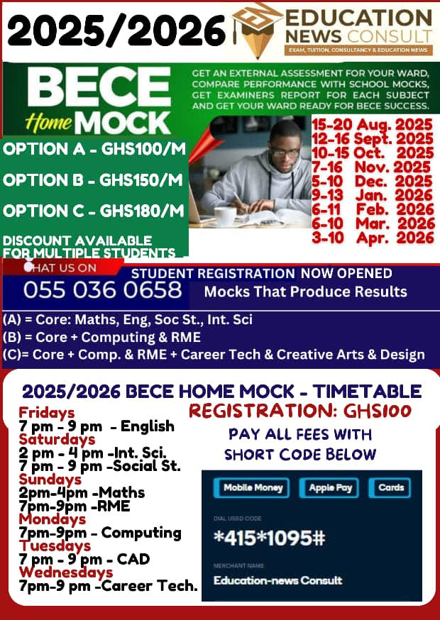

### **Education-News Consult – BECE Prep Mock Schedule (2025/26 Academic Year)**

| **Mock Name** | **Dates** |
| --- | --- |
| Foundation Booster | 23rd – 30th September, 2025 |
| Challenge Booster | 27th October – 3rd November, 2025 |
| Peak Performance Booster | 19th – 23rd January, 2026 |
| Victory Prep Booster | 23rd – 27th February, 2026 |
| Champion’s Booster | 23rd – 27th March, 2026 |
| Final Conquest Booster | 20th – 24th April, 2026 |

### **Mock Options & Charges**

| **Mock Package** | **Price (Per Head)** | **What’s Included** |
| --- | --- | --- |
| Standard Mock Service | GHC 35 | - Question papers (A4 sheets)  - Writing materials  - Expanded marking schemes |
| Pro Mock Service | GHC 50 | - Professional invigilators conduct exams  - Seasoned examiners mark scripts  - Examiner’s report, detailed results & broadsheets within 21 days  - Delivery fee: GHC 50 – GHC 100 (Pick-up available) |

### **Contact Information**

* **Phone:** 0550360658 (WhatsApp and Calls)
* **Location:** Mensah Bar, Dodowa, Accra

**2025/2026 SCHEME OF LEARNING**

**BASIC 4**

**ENGLISH LANGUAGE**

|  |  |  |  |  |  |  |  |  |  |  |  |  |  |  |  |
| --- | --- | --- | --- | --- | --- | --- | --- | --- | --- | --- | --- | --- | --- | --- | --- |
| **WEEKS** | | | | **STRAND** | | | **SUB-STRAND** | | **CONTENT STANDARD** | | | | **RESOURCES** | | |
| 1 | | | | Oral Language | | | Songs | | B4.1.1.1 | | | | Word cards, sentence cards, letter cards, handwriting on a manila card and a class library | | |
| Reading | | | Phonics | | B4.2.2.1 | | | |
| Grammar | | | Nouns | | B4.3.1.1 | | | |
| Writing | | | Penmanship and Handwriting | | B4.4.2.1 | | | |
| Writing Conventions & Grammar Usage | | | Using Punctuation | | B4.5.2.1 | | | |
| Extensive Reading | | | Building the love and culture of reading | | B4.6.1.1 | | | |
| 2 | | | | Oral Language | | | Songs | | B4.1.1.1 | | | | Word cards, sentence cards, letter cards, handwriting on a manila card and a class library | | |
| Reading | | | Phonics | | B4.2.2.1 | | | |
| Grammar | | | Nouns | | B4.3.1.1 | | | |
| Writing | | | Penmanship and Handwriting | | B4.4.2.1 | | | |
| Writing Conventions & Grammar Usage | | | Using Punctuation | | B4.5.2.1 | | | |
| Extensive Reading | | | Building the love and culture of reading | | B4.6.1.1 | | | |
| 3 | | | | Oral Language | | | Songs | | B4.1.1.1. | | | | Word cards, sentence  cards, letter cards, handwriting on a manila card and a class library | | |
| Reading | | | Word Families and Common Digraphs | | B4.2.3.1 | | | |
| Grammar | | | Nouns | | B4.3.1.1 | | | |
| Writing | | | Paragraph Development | | B4. 4.6.1 | | | |
| Writing Conventions & Grammar Usage | | | Using Naming words | | B4.5.3.1 | | | |
| Extensive Reading | | | Building the love and culture of reading | | B4.6.1.1 | | | |
| 4 | | | | Oral Language | | | Poems | | B4.1.3.1 | | | | Word cards, sentence cards, letter cards, handwriting on a manila card and a class library | | |
| Reading | | | Vocabulary | | B4.2.6.1 | | | |
| Grammar | | | Determiners | | B4. 3.2.1 | | | |
|  | | |  | |  | | | |
|  | | | | Writing | | | Writing as a Process | | B4.4.9.1 | | | |  | | |
|  | | | Writing Conventions & Grammar Usage | | | Using Naming words | | | | B4.5.3.1 | |  | |
| Extensive Reading | | | Building the love and culture of reading | | | | B4.6.1.1 | |
| 5 | | | Oral Language | | | Poems | | | | B4.1.3.1 | | Word cards, sentence cards,  letter cards, handwriting on a manila card and a class library | |
| Reading | | | Comprehension | | | | B4.2.7.1 | |
| Grammar | | | Determiners | | | | B4. 3.2.1 | |
| Writing | | | Writing as a Process | | | | B4.4.9.1 | |
| Writing Conventions & Grammar Usage | | | Using Action Words | | | | B4.5.4.1 | |
| Extensive Reading | | | Building the love and culture of reading | | | | B4.6.1.1 | |
|  | | | Oral Language | | | Story Telling | | | | B4.1.4.1 | |  | |
| 6 | | | Reading | | | Diphthongs | | | | B4.2.4.1 | | Word cards, sentence cards, letter cards, handwriting on a manila card and a class library | |
| Grammar | | | Pronouns | | | | B4.3.3.1 | |
| Writing | | | Narrative Writing | | | | B4.4.10.1 | |
| Writing Conventions & Grammar Usage | | | Using Action Words | | | | B4.5.4.1 | |
| Extensive Reading | | | Building the love and culture of reading | | | | B4.6.1.1 | |
| 7 | | | Oral Language | | | Presentation | | | | B4.1.10.1 | | Word cards, sentence cards, letter cards, handwriting on a | |
| Reading | | | Vocabulary | | | | B4.2.6.1 | |
| Grammar | | | Adjectives | | | | B4.3.4.1.1 | |
|  | Writing | | | Letter Writing | | | B4.4.15.1 | | | manila card and a class library | | | |
| Writing Conventions & Grammar Usage | | | Using Qualifying Words – Adjectives | | | B4.5.5.1 | | |
| Extensive Reading | | | Building the love and culture of reading | | | B4.6.1.1 | | |
| 8 | Oral Language | | | Story Telling | | | B4.1.4.1 | | | Word cards, sentence cards, letter cards, handwriting on a manila card and a class library | | | |
| Reading | | | Comprehension | | | B4.2.7.1 | | |
| Grammar | | | Verbs | | | B4.3.5.1 | | |
| Writing | | | Narrative Writing | | | B4.4.10.1 | | |
| Writing Conventions & Grammar Usage | | | Using Adverbs | | | B4.5.6.1 | | |
| Extensive Reading | | | Building the love and culture of reading | | | B4.6.1.1 | | |
| 9 | Oral Language | | | Presentation | | | B4.1.10.1 | | | Word cards, sentence cards, letter cards, handwriting on a manila card and a class library | | | |
| Reading | | | Blends and Consonant Clusters | | | B4.2.5.1 | | |
| Grammar | | | Verbs | | | B4.3.5.1 | | |
| Writing | | | Letter Writing | | | B4.4.15.1 | | |
| Writing Conventions & Grammar Usage | | | Using Simple Prepositions | | | B4.5.7.1 | | |
| Extensive Reading | | | Building the love and culture of reading | | | B4.6.1.1 | | |
| 10 | Oral Language | | | Presentation | | | B4.1.10.1 | | |  | | | |
| Reading | | | Blends and Consonant Clusters | | | B4.2.5.1 | | |
| Grammar | | | Verbs | | | B4.3.5.1 | | |
| Writing | | | Letter Writing | | | B4.4.15.1 | | |
| Writing Conventions & Grammar Usage | | | Using Simple Prepositions | | | B4.5.7.1 | | |
| Extensive Reading | | | Building the love and culture of reading | | | B4.6.1.1 | | |
| 11 | Oral Language | | | Dramatization and Role Play | | | B4.1.5.1 | | | Word cards, sentence cards, letter cards, handwriting on a manila card and a class library | | | |
| Reading | | | Vocabulary | | | B4.2.6.2 | | |
| Grammar | | | Verbs | | | B4.3.5.1 | | |
| Writing | | | Creative/Free Writing | | | B4.4.12.1 | | |
|  | Writing Conventions & Grammar Usage | | | Using Conjunctions | | | B4.5.8.1 | | |  | | | |
| Extensive Reading | | | Building the love and culture of reading | | | B4.6.1.1 | | |
| **12** | Oral Language | | | Presentation | | | B4.1.10.1 | | | Word cards, sentence cards, letter cards, handwriting on a manila card and a | | | |
| Reading | | | Silent Reading | | | B4.2.8.1 | | |
| Grammar | | | Conjunctions | | | B4.3.8.1 | | |

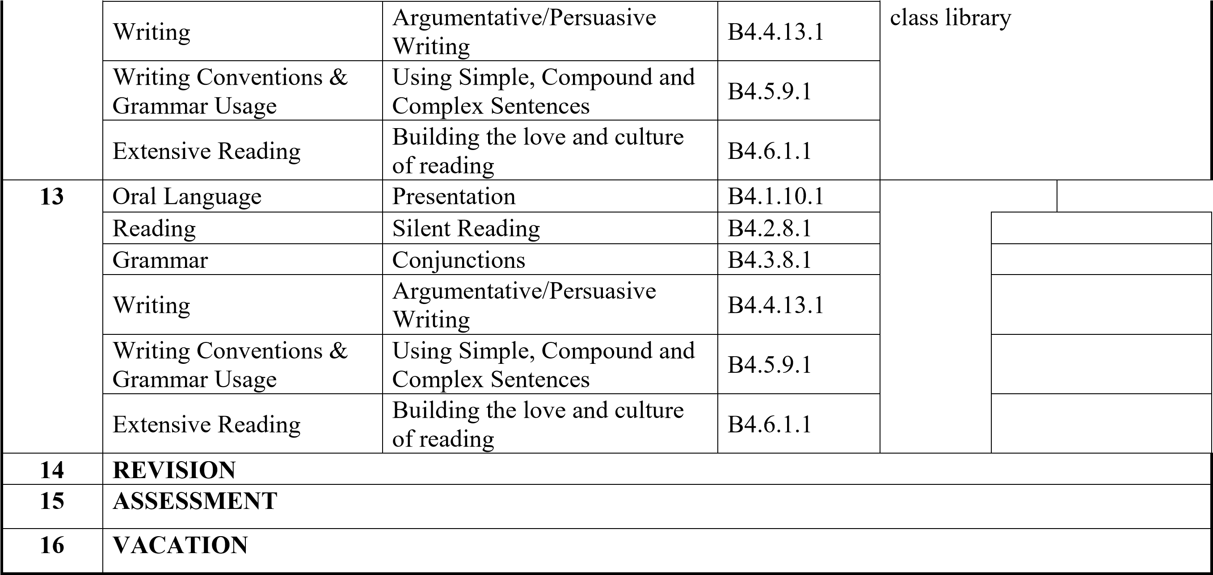

**MATHEMATICS**

|  |  |  |  |  |
| --- | --- | --- | --- | --- |
| **WEEKS** | **STRAND** | **SUB-STRAND** | **CONTENT STANDARD** | **RESOURCES** |
| **1** | Number | Counting, Representation & Cardinality | B4. 1.1.1 | Counters, bundle and loose straws base ten cut square, patterns made from Manila cards, Bundle of sticks |
| **2** | Number | Counting, Representation & Cardinality | B4. 1.1.1 |
| **3** | Number | Counting, Representation & Cardinality | B4. 1.1.1 |
| **4** | Number | Counting, Representation & Cardinality | B4. 1.1.1 |
| **5** | Number | Counting, Representation & Cardinality | B4.1.1.2 | Counters, bundle and loose straws base ten cut square, patterns made from Manila cards, Bundle of sticks |
| **6** | Number | Counting, Representation & Cardinality | B4.1.1.3 |
| **7** | Number | Counting, Representation & Cardinality | B4. 1.1.3 |
| **8** | Number | Counting, Representation & Cardinality | B4. 1.1.3 |  |
| **9** | Number | Number Operations | B4.1.2.1 | Counters, bundle and loose straws base ten cut square, patterns made from Manila cards, Bundle of sticks |
| **10** | Number | Number Operations | B4.1.2.2/3/4 |
| **11** | Number | Number Operations | B4.1.2.5/6 |
| **12** | Number | Fractions | B4.1.3.1  B4.1.3.1 | Paper strips, cut out cards |
| **13** | Number | Fractions | B4.1.3.1  B4.1.3.1 |  |
| **14** | **REVISION** |  |  |  |
| **15** | **ASSESSMENT** |  |  |  |
| **16** | **VACATION** |  |  |  |

**SCIENCE**

|  |  |  |  |  |
| --- | --- | --- | --- | --- |
| **WEEKS** | **STRAND** | **SUB-STRAND** | **CONTENT STANDARD** | **RESOURCES** |
| **1** | Diversity of matter | Living & Non-Living  Things | B4.1.1.1 | Pictures of living and non-living things in the environment |
| **2** | Diversity of matter | Living & Non-Living  Things | B4.1.1.1 |
| **3** | Diversity of matter | Living & Non-Living  Things | B4.1.1.1 |
| **4** | Diversity of matter | Living & Non-Living  Things | B4.1.1.1 | Pictures of living and non-living things in the environment |
| **5** | Diversity of matter | Living & Non-Living  Things | B4.1.1.1 |
| **6** | Diversity of matter | Living & Non-Living  Things | B4.1.1.1 |  |
| **7** | Diversity of matter | Materials | B4.1.2.1 | Metals, woods plastics, soil stones, paper pencil, crayons balloons, water sand, salt ,sugar |
| **8** | Diversity of matter | Materials | B4.1.2.1 |
| **9** | Cycles | Earth Science | B4.2.1.1 | Torch candle matchstick lantern paper pencil pictures of well river stream water |
| **10** | Cycles | Earth Science | B4.2.1.1 |
| **11** | Cycles | Earth Science | B4.2.1.1 |
| **12** | Cycles | Life Cycle Of Organism | B4.2.2.1 |  |
| **13** | Cycles | Life Cycle Of Organism | B4.2.2.1 |  |
| **14** | **REVISION** |  | |  |
| **15** | **ASSESSMENT** |  | |  |
| **16** | **VACATION** |  | |  |

**OUR WORLD OUR PEOPLE**

|  |  |  |  |  |  |
| --- | --- | --- | --- | --- | --- |
| **WEEKS** | **WEEK ENDING** | **STRAND** | **SUB-STRAND** | **CONTENT STANDARD** | **RESOURCES** |
| **1** | 13-09-2024 | All about us | Nature Of God | B4.1.1.1 | Map of Ghana,  atlas,  Pictures, Charts,  Video Clips |
| **2** | 13-09-2024 | All about us | Nature Of God | B4.1.1.1 |
| **3** | 20-09-2024 | All about us | Nature Of God | B4.1.1.1 |
| **4** | 27-09-2024 | All about us | Myself | B4.1.2.1 | Map of Ghana,  atlas,  Pictures, Charts,  Video Clips |
| **5** | 04-10-2024 | All about us | Myself | B4.1.2.1 |
| **6** | 11-10-2024 | All about us | My Family | B4.1.3.1 | Pictures, Charts, Video Clips |
| **7** | 18-10-2024 | All about us | My Family | B4.1.3.1 |
| **8** | 25-10-2024 | All about us | My Family | B4.1.3.1 |  |
| **9** | 01-11-2024 | All about us | Home And School | B4.1.4.1 | Pictures, Charts, Video Clips |
| **10** | 08-11-2024 | All about us | Home And School | B4.1.4.1 |
| **11** | 15-11-2024 | All around us | The Environment & The Weather | B4.2.1.1 | Pictures, Charts, Video Clips |
| **12** | 22-11-2024 | All around us | Plants And Animals | B4.2.2.1 | Pictures, Charts, Video Clips |
| **13** | 29-11-2024 | All around us | Plants And Animals | B4.2.2.1 |  |
| **14** | **06-12-2024** | **REVISION** |  |  |  |
| **15** | **13-12-2024** | **ASSESSMENT** |  |  |  |
| **16** | **20-12-2024** | **VACATION** |  |  |  |

**RELIGIOUS & MORAL EDUCATION**

|  |  |  |  |  |
| --- | --- | --- | --- | --- |
| **WEEKS** | **STRAND** | **SUB-STRAND** | **CONTENT STANDARD** | **RESOURCES** |
| **1** | God’s creation and attributes | God the Creator | B4.1.1.1 | Wall charts, wall words, posters, video clip, etc. |
| **2** | God’s creation and attributes | God the Creator | B4.1.1.1 |
| **3** | God’s creation and attributes | God the Creator | B4.1.1.1 |
| **4** | God’s creation and attributes | God the Creator | B4.1.1.1 | Wall charts, wall words, posters, video clip, etc. |
| **5** | God’s creation and attributes | God the Creator | B4.1.1.1 |
| **6** | God’s creation and attributes | God the Creator | B4.1.1.1 |  |
| **7** | God’s creation and attributes | The Environment | B4.1.2.1 | Wall charts, wall words, posters, video clip, etc. |
| **8** | God’s creation and attributes | The Environment | B4.1.2.1 |
| **9** | God’s creation and attributes | The Environment | B4.1.2.1 | Wall charts, wall words, posters, video clip, etc. |
| **10** | God’s creation and attributes | The Environment | B4.1.2.1 |
| **11** | Religious Practices | Religious Worship | B4.2.1.1 | Wall charts, wall words, posters, video clip, etc. |
| **12** | Religious Practices | Religious Worship | B4.2.1.1 |
| **13** | Religious Practices | Religious Worship | B4.2.1.1 |  |
| **14** | **REVISION** |  |  |  |
| **15** | **ASSESSMENT** |  |  |  |
| **16** | **VACATION** |  |  |  |

**HISTORY**

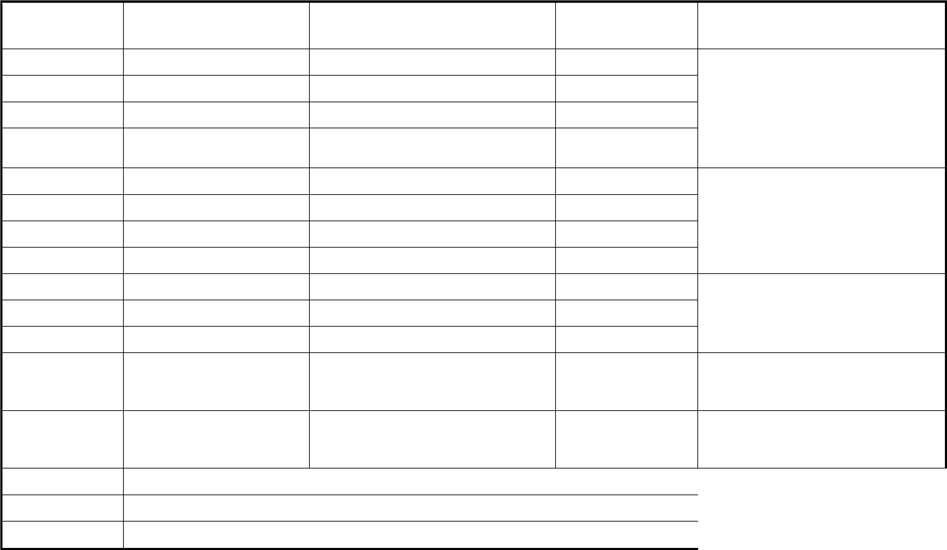 **WEEKS**  **STRAND**  **SUB-STRAND**  **CONTENT RESOURCES**

**STANDARD**

1. My country Ghana Why & how we study History B4.2.1.1 A map of Ghana
2. My country Ghana Why & how we study History B4.2.1.1 showing major
3. My country Ghana Why & how we study History B4.2.1.1 historical locations/
4. My country Ghana Why & how we study History B4.2.1.1 Resource person
5. My country Ghana Why & how we study History B4.2.1.1 Pictures of some
6. My country Ghana Why & how we study History B4.2.1.1 outstanding
7. My country Ghana The People of Ghana B4.2.1.1 entrepreneurs in Ghana
8. My country Ghana The People of Ghana B4.2.1.1
9. My country Ghana The People of Ghana B4.2.2.1 Wall charts, wall
10. My country Ghana The People of Ghana B4.2.2.1 words, posters, video
11. My country Ghana Major Historical Location B4.2.2.1 clip, etc.
12. My country Ghana Major Historical Location B4.2.2.1 Wall charts, wall words,

posters, video clip, etc.

1. My country Ghana Major Historical Location B4.2.2.1
2. **REVISION**
3. **ASSESSMENT**
4. **VACATION**

**CREATIVE ARTS**

|  |  |  |  |  |
| --- | --- | --- | --- | --- |
| **WEEKS** | **STRAND** | **SUB-STRAND** | **CONTENT STANDARD** | **RESOURCES** |
| **1** | Visual Arts | Thinking and Exploring Ideas (Visual Arts) | B4. 1.1.1 | Photos, videos, art paper, colors and traditional art tools, other materials available in the community |
| **2** | Visual Arts | Thinking and Exploring Ideas (Visual Arts) | B4. 1.1.1 |
| **3** | Performing Arts | Thinking and Exploring Ideas (Performing Arts) | B4. 2.1.1 |
| **4** | Visual Arts | Planning, Making and  Composing (Visual Arts) | B4 1.2.2  B4 1.2.3 | Photos, videos, art paper, colors and traditional art tools, other materials available in the community |
| **5** | Performing Arts | Planning, Making and  Composing (Performing Arts) | B4. 2.2.2  B4 2.2.3 |
| **6** | Visual Arts | Displaying and Sharing (Visual Arts) | B4. 1.3.4  B4 1.3.5 | Photos, videos, art paper, colors and traditional art tools, other materials available in the community |
| **7** | Visual Arts | Displaying and Sharing (Visual Arts) | B4. 1.3.4  B4 1.3.5 |
| **8** | Performing Arts | Displaying and Sharing (Performing Arts) | B4. 2.3.4 |
| **9** | Visual Arts | Appreciating and  Appraising (Visual Arts) | B4. 1.4.6  B4 2.3.5 | Photos, videos, art paper, colors and traditional art tools, other materials available in the community |
| **10** | Performing Arts | Appreciating and  Appraising (Performing Arts) | B4.2.4.6  B4 2.4.7 |
| **11** | Visual Arts &  Performing Arts | Thinking and Exploring Ideas School based project (Visual Arts & performing Arts) | B4.1.1.1  B4 2.1.1 | Photos, videos, art paper, colors and traditional art tools, other materials available in the community |
| **12** | Visual Arts &  Performing Arts | Planning, Making and Composing School based project (Visual Arts & Performing | B4.1.1.1  B4 2.1.1 | Photos, videos, art paper, colors and traditional art tools, other materials available in the community |
| **13** | Visual Arts &  Performing Arts | Planning, Making and Composing School based project (Visual Arts & Performing | B4.1.1.1  B4 2.1.1 |  |
| **14** | **REVISION** |  | |  |
| **15** | **ASSESSMENT** |  | |  |
| **16** | **VACATION** |  | |  |

**GHANAIAN LANGUAGE**

|  |  |  |  |  |
| --- | --- | --- | --- | --- |
| **WEEKS** | **STRAND** | **SUB-STRAND** | **CONTENT STANDARD** | **RESOURCES** |
| **1** | Oral Reading | Songs | B4.1.1.1 | Word cards, sentence cards, letter cards |
| **2** | Oral Reading | Songs | B4.1.1.1 |
| **3** | Oral Reading | Poems | B4.1.2.1 |
| **4** | Oral Reading | Story telling | B4.1.4.1 |
| **5** | Reading | Phonics: letter and sound knowledge | B4.2.4.1 | Word cards, sentence cards, letter cards |
| **6** | Reading | Vocabulary: sight and content vocabulary | B4.2.5.1.1 |
| **7** | Writing | Penmanship/Handwriting | B4.3.1.1 | Word cards, sentence cards, letter cards |
| **8** | Composition Writing | Narrative Writing | B4.4.1.1 |
| **9** | Composition Writing | Creative/ Free Writing | B4.4.2.1 |
| **10** | Writing Convention And Grammar Usage | Integrating grammar in written language (capitalization) | B4.5.1.1 | Word cards, sentence cards, letter cards, handwriting on a manila card |
| **11** | Writing Convention And Grammar Usage | Integrating grammar in written language (punctuation) | B4.5.2.1 |
| **12** | Writing Convention And Grammar Usage | Integrating Grammar In Written  Language (Use Of Action Words) | B4.5.3.1 |
| **13** | Extensive Reading | Building the love and culture of reading in learners | B4.6.1.1 | Word cards, sentence cards, letter cards, class library |
| **14** | **REVISION** |  |  |  |
| **15** | **ASSESSMENT** |  |  |  |
| **16** | **VACATION** |  |  |  |

**COMPUTING**

|  |  |  |  |  |
| --- | --- | --- | --- | --- |
| **WEEKS** | **STRAND** | **SUB-STRAND** | **CONTENT STANDARD** | **RESOURCES** |
| **1** | Introduction To Computing | Generation of computers | B4.1.1.1 | Mouse, keyboard monitor, system unit and its components |
| **2** | Introduction To Computing | Generation of computers | B4.1.1.1 |
| **3** | Introduction To Computing | Generation of computers | B4.1.1.1 |
| **4** | Introduction To Computing | Generation of computers | B4.1.1.1 | Mouse, keyboard monitor, system unit and its components |
| **5** | Introduction To Computing | Generation of computers | B4.1.1.1 |
| **6** | Introduction To Computing | Generation of computers | B4.1.1.1 | Mouse, keyboard monitor, system unit and its components |
| **7** | Introduction To Computing | Generation of computers | B4.1.1.1 |
| **8** | Introduction To Computing | Generation of computers | B4.1.1.1 |  |
| **9** | Introduction To Computing | Introduction to MS Windows  Interface | B4.1.2.1 | Projected examples of personalized desktop background |
| **10** | Introduction To Computing | Introduction to MS Windows  Interface | B4.1.2.1 |
| **11** | Introduction To Computing | Introduction to MS Windows  Interface | B4.1.2.1 | Projected examples of personalized desktop background |
| **12** | Introduction To Computing | Introduction to MS Windows  Interface | B4.1.2.1 |
| **13** | Introduction To Computing | Introduction to MS Windows  Interface | B4.1.2.1 |  |
| **14** | **REVISION** | | |  |
| **15** | **ASSESSMENT** | | |  |
| **16** | **VACATION** | | |  |

FRENCH

|  |  |  |  |
| --- | --- | --- | --- |
| **WEEK** | **STRAND** | **SUB-STRAND** | **CONTENT STANDARDS** |
| **1** | L’identité | Saluer et prendre congé | Compréhension Orale  Production Orale  Compréhension Écrite  Production Écrite |
| **2** | L’identité | Saluer et prendre congé | Compréhension Orale  Production Orale  Compréhension Écrite  Production Écrite |
| **3** | L’identité | Saluer et prendre congé | Compréhension Orale  ProductionOrale  Compréhension Écrite  Production Écrite |
| **4** | L’identité | Saluer et prendre congé |  |
| **5** | L’identité | Se présenter | Compréhension Orale  ProductionOrale  Compréhension Écrite  Production Écrite |
| **6** | L’identité | Se présenter | Compréhension Orale  ProductionOrale  Compréhension Écrite  Production Écrite |
| **7** | L’identité | Se présenter | Compréhension Orale  ProductionOrale  Compréhension Écrite  Production Écrite |
| **8** | L’identité | Présenter quelqu'un | Compréhension Orale  ProductionOrale  Compréhension Écrite  Production Écrite |
| **9** | L’identité | Présenter quelqu'un | Compréhension Orale  ProductionOrale  Compréhension Écrite  Production Écrite |
| **10** | L’identité | Décrire quelqu'un | Compréhension Orale  ProductionOrale |
| **11** | L’identité | Décrire quelqu'un | Compréhension Orale  ProductionOrale  Compréhension Écrite  Production Écrite |
| **12** | L’identité | Décrire la famille et les liens familiaux | Compréhension Orale  ProductionOrale  Compréhension Écrite  Production Écrite |
| **13** | L’identité | Décrire la famille et les liens familiaux |  |
| **14** | **REVISION** |  | |
| **15** | **ASSESSMENT** |  | |
| **16** | **VACATION** |  | |