

**EDUCATION-NEWS CONSULT**

**2025/2026 SCHEME OF LERNING**

**0550360658**

[**www.educationnewsconsult.com**](http://www.educationnewsconsult.com)



**Free Online quizzes:** [**www.beceprep.com**](http://www.beceprep.com) **: Downloads and Mock Papers**

**Other Services**

Online Mock Quizzes for BECE and All Classes - [**www.beceprep.com**](http://www.beceprep.com)

BECE Home Mocks

BECE School Mocks

End of term exam questions – hard Copies and Soft Copies

Mock Questions and Answers (Online –MS WORD)

BECE SMARTPICK PREDICTOR

SOFTWARE FOR MONITORING BECE CANDIDATES PERFORMANCE WHICH HELPS PREDICT CATEGORIES FROM WHICH SCHOOLS SHOULD BE CHOSEN

Chat Us on WhatsApp **550360658** for more information

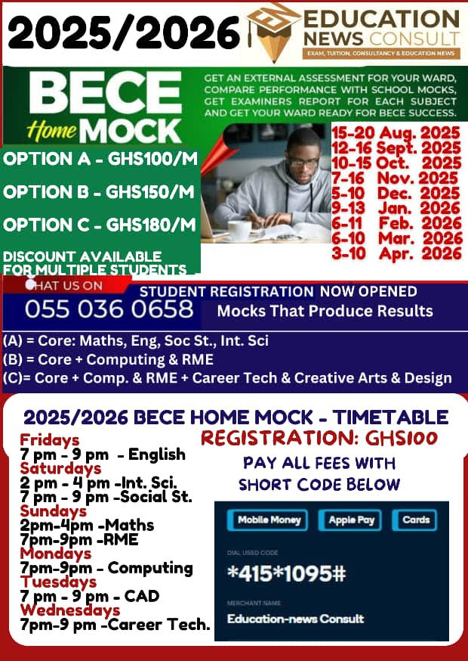

### **Education-News Consult – BECE Prep Mock Schedule (2025/26 Academic Year)**

| **Mock Name** | **Dates** |
| --- | --- |
| Foundation Booster | 23rd – 30th September, 2025 |
| Challenge Booster | 27th October – 3rd November, 2025 |
| Peak Performance Booster | 19th – 23rd January, 2026 |
| Victory Prep Booster | 23rd – 27th February, 2026 |
| Champion’s Booster | 23rd – 27th March, 2026 |
| Final Conquest Booster | 20th – 24th April, 2026 |

### **Mock Options & Charges**

| **Mock Package** | **Price (Per Head)** | **What’s Included** |
| --- | --- | --- |
| Standard Mock Service | GHC 35 | - Question papers (A4 sheets)  - Writing materials  - Expanded marking schemes |
| Pro Mock Service | GHC 50 | - Professional invigilators conduct exams  - Seasoned examiners mark scripts  - Examiner’s report, detailed results & broadsheets within 21 days  - Delivery fee: GHC 50 – GHC 100 (Pick-up available) |

### **Contact Information**

* **Phone:** 0550360658 (WhatsApp and Calls)
* **Location:** Mensah Bar, Dodowa, Accra

**2025/2026 SCHEME OF LEARNING**

**BASIC 6**

ENGLISH LANGUAGE

|  |  |  |  |  |
| --- | --- | --- | --- | --- |
| **WEEKS** | **STRAND** | **SUB-STRAND** | **CONTENT STANDARD** | **RESOURCES** |
| 1 | Oral Language | Songs | B6.1.1.1 | Word cards, sentence cards, letter cards, handwriting on a manila card and a class library |
| Reading | Phonics | B6.2.2.1 |
| Grammar | Nouns | B6.3.1.1 |
| Writing | Penmanship and Handwriting | B6.4.2.1 |
| Writing  Conventions &  Grammar Usage | Using Capitalization | B5.5.1.1 |
| Extensive Reading | Building the love and culture of reading | B6.6.1.1 |
| 2 | Oral Language | Songs | B6.1.1.1 | Word cards, sentence cards, letter cards, handwriting on a manila card and a class library |
| Reading | Phonics | B6.2.2.1 |
| Grammar | Nouns | B6.3.1.1 |
| Writing | Penmanship and Handwriting | B6.4.2.1 |
| Writing  Conventions &  Grammar Usage | Using Capitalization | B5.5.1.1 |
| Extensive Reading | Building the love and culture of reading | B6.6.1.1 |
| 3 | Oral Language | Songs | B6.1.1.1 | Word cards, sentence cards, letter cards, handwriting on a manila card and a class library |
| Reading | Word Families and Common Digraphs | B6.2.3.1 |
| Grammar | Nouns | B6.3.1.1 |
| Writing | Paragraph Development | B6.4.3.1 |
| Writing  Conventions &  Grammar Usage | Using Punctuation | B6.5.2.1 |
| Extensive Reading | Building the love and culture of reading | B6.6.1.1 |
| 4 | Oral Language | Poems | B6.1.3.1 | Word cards, sentence cards, letter cards, handwriting on a manila card and a class library |
| Reading | Vocabulary | B6.2.6.1 |
| Grammar | Determiners | B6.3.2.1 |
| Writing | Writing as a Process | B6.4.9.1 |
| Writing  Conventions &  Grammar Usage | Using Naming words | B6.5.3.1 |

|  |  |  |  |  |
| --- | --- | --- | --- | --- |
|  | Extensive Reading | Building the love and culture of reading | B6.6.1.1 |  |
| 5 | Oral Language | Poems | B6.1.3.1 | Word cards, sentence cards, |
| Reading | Comprehension | B6.2.7.1 |
|  | Grammar | Determiners | B6.3.2.1 | letter cards, handwriting on a manila card and a class library |
| Writing | Writing as a Process | B6.4.9.1 |
| Writing  Conventions &  Grammar Usage | Using Naming words | B6.5.3.1 |
| Extensive Reading | Building the love and culture of reading | B6.6.1.1 |
| 6 | Oral Language | Story Telling | B6.1.4.1 | Word cards, sentence cards, letter cards, handwriting on a manila card and a class library |
| Reading | Diphthongs | B6.2.4.1 |
| Grammar | Pronouns | B6.3.3.1 |
| Writing | Narrative Writing | B6.4.10.1 |
| Writing  Conventions &  Grammar Usage | Using Action Words | B6.5.4.1 |
| Extensive Reading | Building the love and culture of reading | B6.6.1.1 |
| 7 | Oral Language | Presentation | B6.1.10.1 | Word cards, sentence cards, letter cards, handwriting on a manila card  and a class library |
| Reading | Vocabulary | B6.2.6.1 |
| Grammar | Adjectives | B6.3.4.1.1 |
| Writing | Paragraph Development | B6.4.3.1 |

|  |  |  |  |  |
| --- | --- | --- | --- | --- |
|  | Writing |  |  |  |
|  | Conventions & Grammar Usage | Using Action Words | B6.5.4.1 |  |
| Extensive Reading | Building the love and culture of reading | B6.6.1.1 |
| 8 | Oral Language | Story Telling | B6.1.4.1 | Word cards, sentence cards, letter cards, handwriting on a manila card  and a class library |
| Reading | Comprehension | B6.2.7.1 |
| Grammar | Verbs | B6.3.5.1 |
| Writing | Narrative Writing | B6.4.10.1 |
| Writing  Conventions &  Grammar Usage | Using Qualifying WordsAdjectives | B6.5.5.1 |
| Extensive Reading | Building the love and culture of reading | B6.6.1.1 |
| 9 | Oral Language | Presentation | B6.1.10.1 | Word cards, sentence cards, letter cards, handwriting on |
| Reading | Blends and Consonant  Clusters | B6.2.5.1 |
| Grammar | Verbs | B6.3.5.1 |

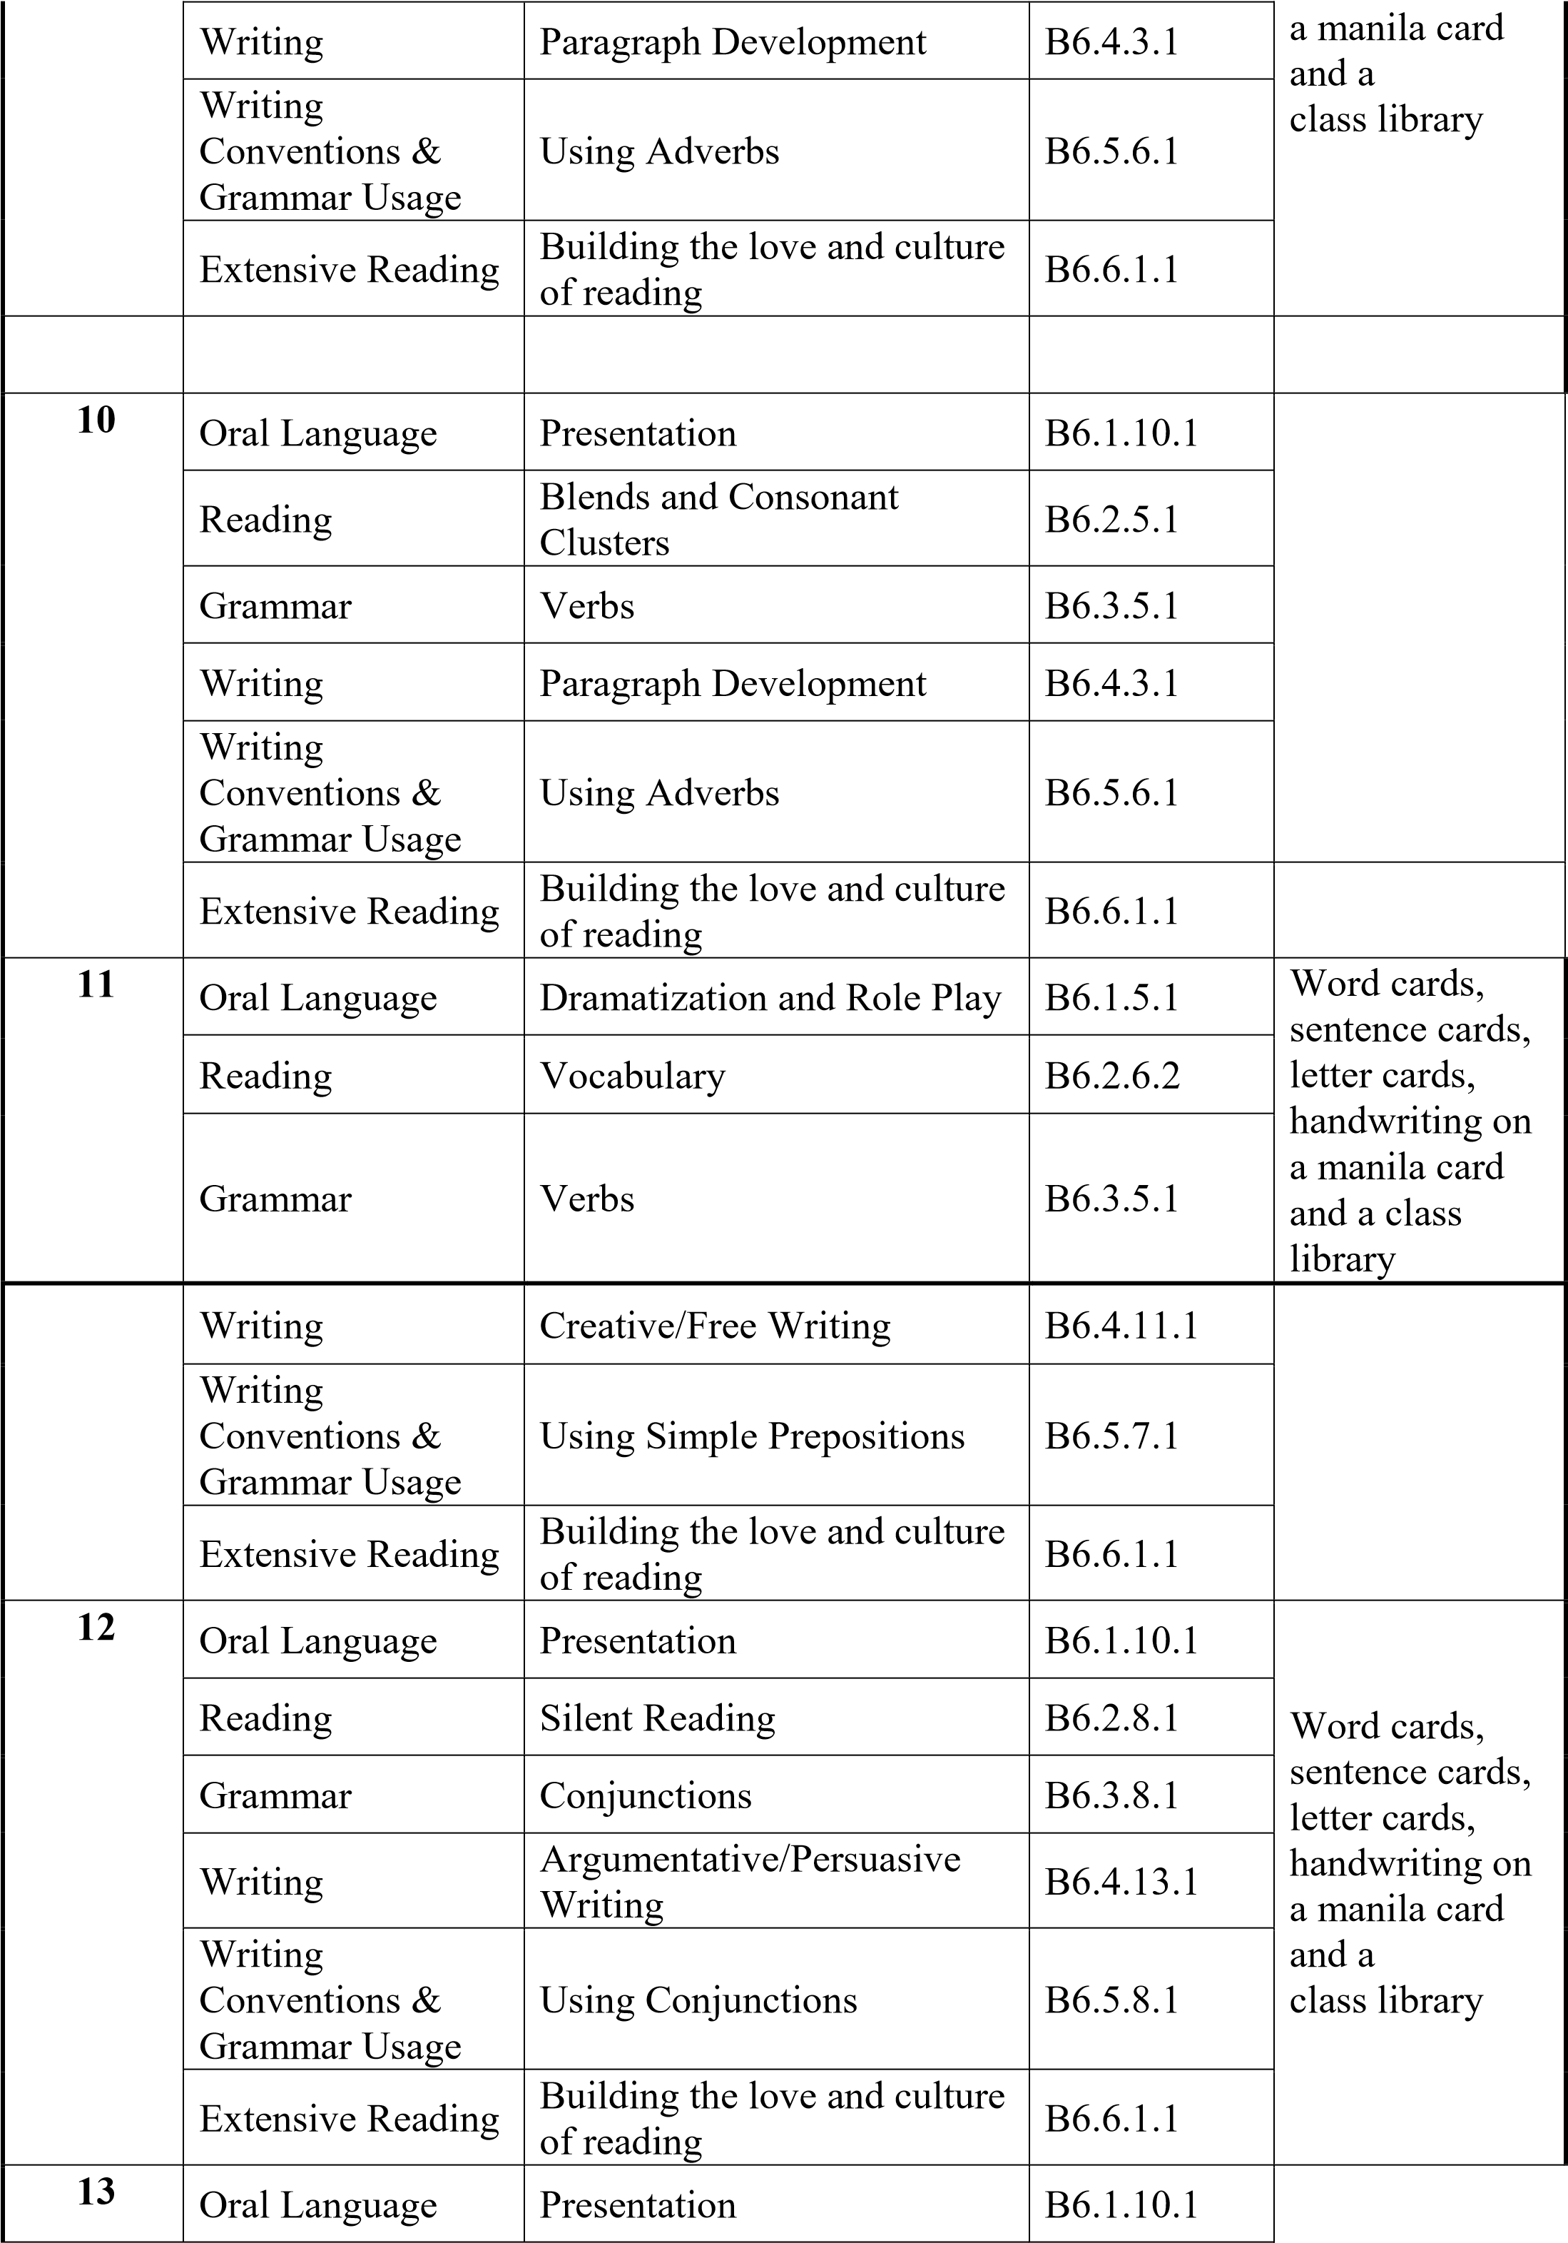

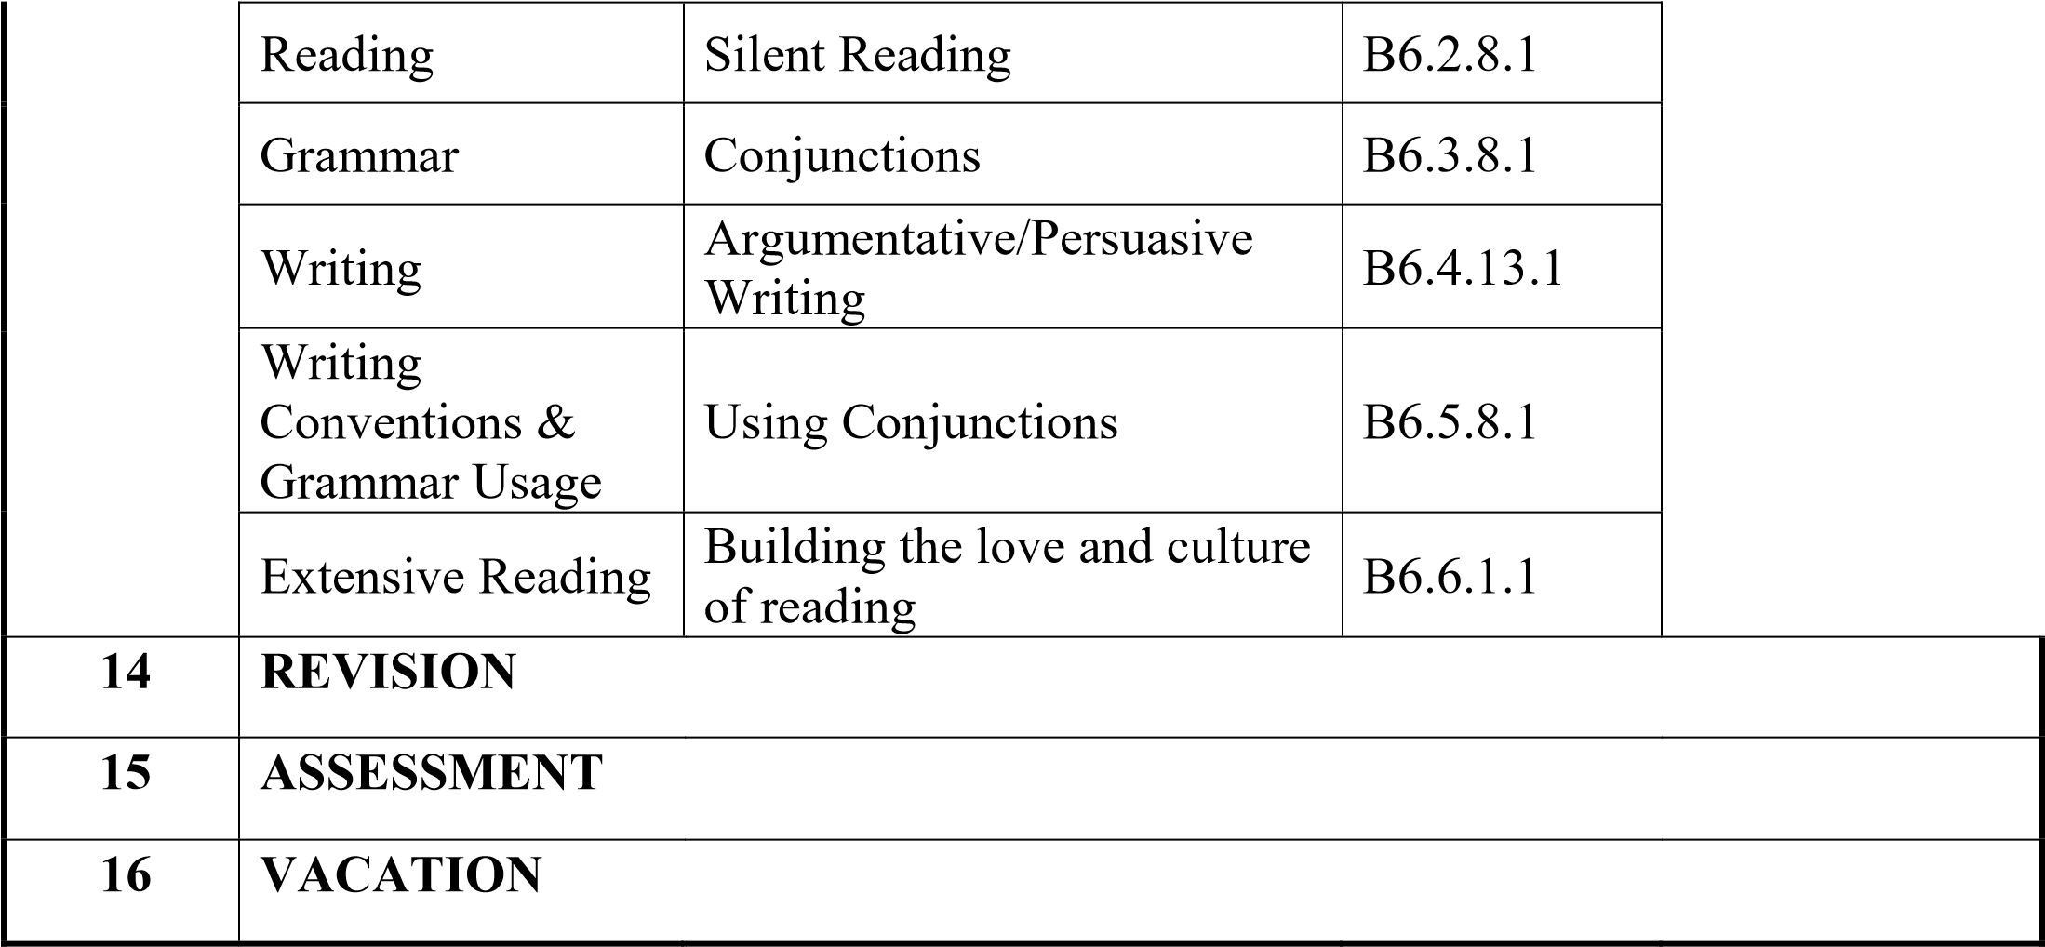

**MATHEMATICS**

|  |  |  |  |  |
| --- | --- | --- | --- | --- |
| **WEEKS** | **STRAND** | **SUB-STRAND** | **CONTENT STANDARD** | **RESOURCES** |
| **1** | Number | Counting, Representation And Cardinality | B6.1.1.1 | Counters, bundle and loose straws base ten cut square |
| **2** | Number | Counting, Representation And Cardinality | B6.1.1.1 |
| **3** | Number | Counting Representation And Cardinality | B6.1.1.1 |
| **4** | Number | Counting, Representation And Cardinality | B6.1.1.1 | Counters, bundle and loose straws base ten cut square |
| **5** | Number | Counting, Representation And Cardinality | B6.1.1.1 |
| **6** | Number | Number Operations | B6.1.2.1 |
| **7** | Number | Number Operations | B6.1.2.1 | Counters, bundle and loose straws base ten cut square |
| **8** | Number | Number Operations | B6.1.2.3/4 |
| **9** | Number | Fractions | B6.1.3.1 | Paper strips, cut out cards, Counters, bundle and loose straws |
| **10** | Number | Fractions | B6.1.3.1 |
| **11** | Number | Ratio And Proportion | B6.1.4.1 | Counters, bundle and loose straws base ten cut square |
| **12** | Number | Ratio And Proportion | B6.1.4.1  B6.1.4.2 |
| **13** | Number | Ratio And Proportion | B6.1.4.1  B6.1.4.2 |  |
| **14** | **REVISION** | |  |  |
| **15** | **ASSESSMENT** | |  |  |
| **16** | **VACATION** | |  |  |

**SCIENCE**

|  |  |  |  |  |
| --- | --- | --- | --- | --- |
| **WEEKS** | **STRAND** | **SUB-STRAND** | **CONTENT STANDARD** | **RESOURCES** |
| **1** | Diversity Of Matter | Living And Non- Living Things | B6.1.1.1 | Pictures of Plants and animals in the environment |
| **2** | Diversity Of Matter | Living And Non- Living Things | B6.1.1.1 |
| **3** | Diversity Of Matter | Living And Non- Living Things | B6.1.1.1 |
| **4** | Diversity Of Matter | Living And Non- Living Things | B6.1.1.1 |  |
| **5** | Diversity Of Matter | Materials | B6.1.2.1 | Metals, woods plastics soil stones paper pencil crayons balloons water sand salt sugar |
| **6** | Diversity Of Matter | Materials | B6.1.2.1 |
| **7** | Diversity Of Matter | Materials | B6.1.2.1 |
| **8** | Cycle | Earth Science | B6.2.1.1 | Torch candle matchstick lantern paper pencil pictures of well river stream water |
| **9** | Cycle | Earth Science | B6.2.1.1 |
| **10** | Cycle | Earth Science | B6.2.1.1 | Torch candle matchstick lantern paper pencil pictures of well river stream water |
| **11** | Cycle | Earth Science | B6.2.1.1 |
| **12** | Cycle | Life Cycle Of Organism | B6.2.2.1 | Plants seeds hand lens paper pencil fruits |
| **13** | Cycle | Life Cycle Of Organism | B6.2.2.1 |  |
| **14** | **REVISION** |  |  |  |
| **15** | **ASSESSMENT** |  |  |  |
| **16** | **VACATION** |  |  |  |

**OUR WORLD OUR PEOPLE**

|  |  |  |  |  |
| --- | --- | --- | --- | --- |
| **WEEKS** | **STRAND** | **SUB-STRAND** | **CONTENT STANDARD** | **RESOURCES** |
| **1** | All About Us | Nature Of God | B6.1.1.1 | Map of Ghana,  atlas,  Pictures, Charts,  Video Clips |
| **2** | All About Us | Nature Of God | B6.1.1.1 |
| **3** | All About Us | Nature Of God | B6.1.1.1 |
| **4** | All About Us | Nature Of God | B6.1.1.1 |  |
| **5** | All About Us | Myself | B6.1.2.1 | Map of Ghana,  atlas,  Pictures, Charts,  Video Clips |
| **6** | All About Us | Myself | B6.1.2.1 |
| **7** | All About Us | My Family | B6.1.3.1 | Pictures, Charts, Video Clips |
| **8** | All About Us | My Family | B6.1.3.1 |
| **9** | All About Us | Home And School | B6.1.4.1 | Pictures, Charts, Video Clips |
| **10** | All About Us | The Environment And The Weather | B6.2.1.1 | Pictures, Charts, Video Clips |
| **11** | All Around Us | Plants And Animals | B6.2.2.1 | Pictures, Charts, Video Clips |
| **12** | All Around Us | Plants And Animals | B6.2.2.1 |
| **13** | All Around Us | Plants And Animals | B6.2.2.1 |  |
| **14** | **REVISION** |  |  |  |
| **15** | **ASSESSMENT** |  |  |  |
| **16** | **VACATION** |  |  |  |

**RELIGIOUS & MORAL EDUCATION**

|  |  |  |  |  |
| --- | --- | --- | --- | --- |
| **WEEKS** | **STRAND** | **SUB-STRAND** | **CONTENT STANDARD** | **RESOURCES** |
| **1** | God’s Creation And Attributes | God The Creator | B6 2.2.1 | Wall Charts, Wall Words, Posters, etc. |
| **2** | God’s Creation And Attributes | God The Creator | B6 2.2.1 | Wall Charts, Wall Words, Posters, etc. |
| **3** | God’s Creation And Attributes | God The Creator | B6 2.2.1 | Wall Charts, Wall Words, Posters, etc. |
| **4** | God’s Creation And Attributes | God The Creator | B6 2.2.1 | Wall Charts, Wall Words, Posters, etc. |
| **5** | God’s Creation And Attributes | God The Creator | B6 2.2.1 | Wall Charts, Wall Words, Posters, etc. |
| **6** | God’s Creation And Attributes | God The Creator | B6 2.2.1 |  |
| **7** | God’s Creation And Attributes | The Environment | B6 3.4.1 | Wall Charts, Wall Words, Posters, etc. |
| **8** | God’s Creation And Attributes | The Environment | B6 3.4.1 | Wall Charts, Wall Words, Posters, etc. |
| **9** | God’s Creation And Attributes | The Environment | B6 3.4.1 | Wall Charts, Wall Words, Posters, etc. |
| **10** | God’s Creation And Attributes | The Environment | B6 3.4.1 | Wall Charts, Wall Words, Posters, etc. |
| **11** | Religious Practices | Religious Worship | B6 4.1.1 | Wall Charts, Wall Words, Posters, etc. |
| **12** | Religious Practices | Religious Worship | B6 4.1.1 | Wall Charts, Wall Words, Posters, etc. |
| **13** | Religious Practices | Religious Worship | B6 4.1.1 |  |
| **14** | **REVISION** |  |  | |
| **15** | **ASSESSMENT** |  |  | |
| **16** | **VACATION** |  |  | |

**HISTORY**

|  |  |  |  |  |
| --- | --- | --- | --- | --- |
| **WEEKS** | **STRAND** | **SUB-STRAND** | **CONTENT STANDARD** | **RESOURCES** |
| **1** | Europeans In Ghana | Impact Of European Presence | B6.3.4.1 | Wall charts, wall words, posters, video clip, etc. |
| **2** | Europeans In Ghana | Impact Of European Presence | B6.3.4.1 |
| **3** | Europeans In Ghana | Impact Of European Presence | B6.3.4.1 |
| **4** | Europeans In Ghana | Impact Of European Presence | B6.3.4.1 | Wall charts, wall words, posters, video clip, etc. |
| **5** | Europeans In Ghana | Impact Of European Presence | B6.3.4.1 |
| **6** | Europeans In Ghana | Impact Of European Presence | B6.3.4.1 | Wall charts, wall words, posters, video clip, etc. |
| **7** | Europeans In Ghana | Impact Of European Presence | B6.3.4.1 |
| **8** | Europeans In Ghana | Impact Of European Presence | B6.3.4.1 |  |
| **9** | Colonization & Development | Political Development | B6.4.4.1 | Wall charts, wall words, posters, video clip, etc. |
| **10** | Colonization & Development | Political Development | B6.4.4.1 |
| **11** | Colonization & Development | Political Development | B6.4.4.1 | Wall charts, wall words, posters, video clip, etc. |
| **12** | Colonization & Development | Political Development | B6.4.4.1 |
| **13** | Colonization & Development | Political Development | B6.4.4.1 |  |
| **14** | **REVISION** |  |  |  |
| **15** | **ASSESSMENT** |  |  |  |
| **16** | **VACATION** |  |  |  |

**CREATIVE ARTS**

|  |  |  |  |  |
| --- | --- | --- | --- | --- |
| **WEEKS** | **STRAND** | **SUB-STRAND** | **CONTENT STANDARD** | **RESOURCES** |
| **1** | Visual Arts | Thinking and Exploring Ideas (Visual Arts) | B6. 1.1.1 | Photos, videos, art paper, colors and traditional art tools, |
| **2** | Visual Arts | Thinking and Exploring Ideas (Visual Arts) | B6. 1.1.1 |
| **3** | Performing  Arts | Thinking and Exploring Ideas (Performing Arts) | B6. 2.1.1 |  |
| **4** | Visual Arts | Planning, Making and  Composing  (Visual Arts) | B6.1.2.2 B6. 1.2.3 | Photos, videos, art paper, colors and traditional art tools, |
| **5** | Performing  Arts | Planning, Making and  Composing  (Performing Arts) | B6.2.2.2  B6.2.2.3 |
| **6** | Visual Arts | Displaying and Sharing (Visual Arts) | B6.1.3.4  B6.1.3.5 | Photos, videos, art paper, colors and traditional art tools, |
| **7** | Visual Arts | Displaying and Sharing (Visual Arts) | B6.1.3.4  B6.1.3.5 |
| **8** | Performing  Arts | Displaying and Sharing (Performing Arts) | B6.2.3.4  B6.2.3.5 |
| **9** | Visual Arts | Appreciating and  Appraising (Visual Arts) | B6.1.4.6  B6.1.4.7 | Photos, videos, art paper, colors and traditional art tools, |
| **10** | Performing  Arts | Appreciating and  Appraising (Performing Arts) | B6.2.4.6  B6.2.4.7 |
| **11** | Visual &  Performing  Arts | Thinking and Exploring  Ideas (School Based  Project) | B6.1.1.1  B6.2.1.1 | Photos, videos, art paper, colors and traditional art tools, |
| **12** | Visual &  Performing  Arts | Planning, Making and  Composing  (School Based Project) | B6.1.1.1  B6.2.1.1 | Photos, videos, art paper, colors and traditional art tools, |
| **13** | Visual &  Performing Arts | Planning, Making and  Composing  (School Based Project) | B6.1.1.1  B6.2.1.1 |  |
| **14** | **REVISION** | |  |  |
| **15** | **ASSESSMENT** | |  |  |
| **16** | **VACATION** | |  |  |

**GHANAIAN LANGUAGE**

|  |  |  |  |  |
| --- | --- | --- | --- | --- |
| **WEEKS** | **STRAND** | **SUB-STRAND** | **CONTENT STANDARD** | **RESOURCES** |
| **1** | Oral Language | Songs | B6.1.1.1 | Word Cards, Sentence  Cards, Letter Cards,  Handwriting On A  Manila  Card |
| **2** | Oral Language | Songs | B6.1.1.1 |
| **3** | Oral Language | Poems | B6.1.3.1 |
| **4** | Oral Language | Story Telling | B6.1.4.1 |
| **5** | Reading | Phonics: Letter And Sound Knowledge | B6.2.4.1 | Word Cards, Sentence  Cards, Letter Cards,  Handwriting On A  Manila |
| **6** | Reading | Phonics: Letter And Sound Knowledge | B6.2.4.1 |
| **7** | Reading | Vocabulary: Sight And Content Vocabulary | B6.2.5.1 | Card |
| **8** | Writing | Penmanship And Handwriting | B6.3.1.1 | Word Cards, Sentence  Cards, Letter Cards,  Handwriting On A  Manila  Card |
| **9** | Composition Writing | Narrative Writing | B6.4.1.1 |
| **10** | Composition Writing | Creative Writing | B6.4.2.1 |
| **11** | Writing  Convention | Use Of Capitalization | B6.5.1.1 | Word Cards, Sentence  Cards, Letter Cards,  Handwriting On A  Manila  Card |
| **12** | Writing  Convention | Use Of Punctuation  Use Of Action Words | B6.5.2.1 |
| **13** | Writing  Convention | Use Of Punctuation  Use Of Action Words | B6.5.2.1 |  |
| **14** | **REVISION** |  |  |  |
| **15** | **ASSESSMENT** |  |  |  |
| **16** | **VACATION** |  |  |  |

**COMPUTING**

|  |  |  |  |  |  |
| --- | --- | --- | --- | --- | --- |
| **WEEKS** | **STRAND** | **SUB-STRAND** | | **CONTENT STANDARD** | **RESOURCES** |
| **1** | Word Processing | Generation Of Computers |  | B6.3.1.1 | Images of clipboard, styles, fonts, paragraph  and editing in in the Home Tab of MS – Word. |
| **2** | Word Processing | Generation Of Computers |  | B6.3.1.1 |
| **3** | Word Processing | Generation Of Computers |  | B6.3.1.1 |
| **4** | Word Processing | Introduction To  MSWindows  Interface |  | B6.5.1.1 | Pictures or projected images |
| **5** | Word Processing | Introduction To  MSWindows  Interface |  | B6.5.1.1 |
| **6** | Programming And Databases | Introduction  MSWindows  Interface | To | B6.5.1.1 |
| **7** | Programming And Database | Introduction  MSWindows  Interface | To | B6.5.1.1 |
| **8** | Programming And Databases | Data, Sources And Usage | | B6.5.3.1 | Pictures or projected images |
| **9** | Programming And Databases | Data, Sources And Usage | | B6.5.3.1 |
| **10** | Internet And Social Media | Data, Sources And Usage | | B6.5.3.1 |  |
| **11** | Internet And Social Media | Data, Sources And Usage | | B6.6.1.1 | Pictures or projected images |
| **12** | Internet And Social Media | Technology In The Community | | B6.6.1.1 |
| **13** | Internet And Social Media | Technology In The Community | | B6.6.1.1 |  |
| **14** | **REVISION** |  | |  |  |
| **15** | **ASSESSMENT** |  | |  |  |
| **16** | **VACATION** |  | |  |  |

**FRENCH**

|  |  |  |  |
| --- | --- | --- | --- |
| **WEEK** | **STRAND** | **SUB-STRAND** | **CONTENT** |
| **1** |  | Saluer et prendre congé | **STANDARDS**  Compréhension Orale  Production Orale  Compréhension Écrite  Production Écrite |
| L’identité |
| **2** | L’identité | Saluer et prendre congé | Compréhension Orale  Production Orale  Compréhension Écrite  Production Écrite |
| **3** | L’identité | Saluer et prendre congé | Compréhension Orale  Production Orale  Compréhension Écrite  Production Écrite |
| **4** | L’identité | Se présenter | Compréhension Orale  ProductionOrale  Compréhension Écrite  Production Écrite |
| **5** | L’identité | Se présenter |  |
| **6** | L’identité | Se présenter | Compréhension Orale  ProductionOrale  Compréhension Écrite  Production Écrite |
| **7** | L’identité | Présenter quelqu'un | Compréhension Orale  ProductionOrale  Compréhension Écrite  Production Écrite |
| **8** | L’identité | Présenter quelqu'un | Compréhension Orale  ProductionOrale  Compréhension Écrite  Production Écrite |
| **9** | L’identité | Décrire quelqu'un | Compréhension Orale  ProductionOrale  Compréhension Écrite  Production Écrite |
| **10** | L’identité | Décrire quelqu'un | Compréhension Orale  ProductionOrale  Compréhension Écrite  Production Écrite |
| **11** | L’identité | Décrire la famille et les liens familiaux | Compréhension Orale  ProductionOrale  Compréhension Écrite  Production Écrite |
| **12** | L’identité | Décrire la famille et les liens familiaux | Compréhension Orale  ProductionOrale  Compréhension Écrite  Production Écrite |
| **13** | L’identité | Décrire la famille et les liens familiaux |  |
| **14** | **REVISION** |  |  |
| **15** | **ASSESSMENT** |  |  |
| **16** | **VACATION** |  |  |