

**EDUCATION-NEWS CONSULT**

**2025/2026 SCHEME OF LERNING**

**0550360658**

[**www.educationnewsconsult.com**](http://www.educationnewsconsult.com)



**Free Online quizzes:** [**www.beceprep.com**](http://www.beceprep.com) **: Downloads and Mock Papers**

**Other Services**

Online Mock Quizzes for BECE and All Classes - [**www.beceprep.com**](http://www.beceprep.com)

BECE Home Mocks

BECE School Mocks

End of term exam questions – hard Copies and Soft Copies

Mock Questions and Answers (Online –MS WORD)

BECE SMARTPICK PREDICTOR

SOFTWARE FOR MONITORING BECE CANDIDATES PERFORMANCE WHICH HELPS PREDICT CATEGORIES FROM WHICH SCHOOLS SHOULD BE CHOSEN

Chat Us on WhatsApp **550360658** for more information

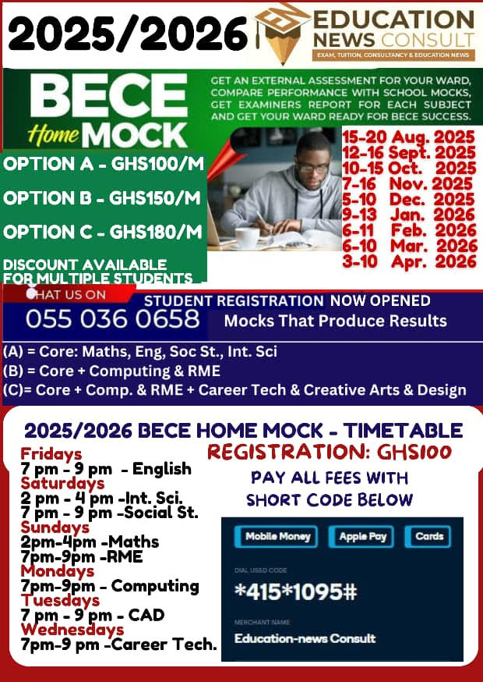

### **Education-News Consult – BECE Prep Mock Schedule (2025/26 Academic Year)**

| **Mock Name** | **Dates** |
| --- | --- |
| Foundation Booster | 23rd – 30th September, 2025 |
| Challenge Booster | 27th October – 3rd November, 2025 |
| Peak Performance Booster | 19th – 23rd January, 2026 |
| Victory Prep Booster | 23rd – 27th February, 2026 |
| Champion’s Booster | 23rd – 27th March, 2026 |
| Final Conquest Booster | 20th – 24th April, 2026 |

### **Mock Options & Charges**

| **Mock Package** | **Price (Per Head)** | **What’s Included** |
| --- | --- | --- |
| Standard Mock Service | GHC 35 | - Question papers (A4 sheets)  - Writing materials  - Expanded marking schemes |
| Pro Mock Service | GHC 50 | - Professional invigilators conduct exams  - Seasoned examiners mark scripts  - Examiner’s report, detailed results & broadsheets within 21 days  - Delivery fee: GHC 50 – GHC 100 (Pick-up available) |

### **Contact Information**

* **Phone:** 0550360658 (WhatsApp and Calls)
* **Location:** Mensah Bar, Dodowa, Accra

**2025/2026 SCHEME OF LEARNING**

**BASIC 9**

**MATHEMATICS TERM 1 TERMLY SCHEME OF LEARNING**

|  |  |  |  |  |
| --- | --- | --- | --- | --- |
| **WEEKS** | **STRAND** | **SUB STRAND** | **INDICATORS** | **RESOURCES** |
| **1&2** | Number | Number &  Numeration System | B9.1.1.1.1-2 | Counters, bundle and loose straws. |
| **3** | Number | Number &  Numeration System | B9.1.1.2.1-2 | Counters, bundle and loose straws. |
| **4** | Number | Number Operations | B9.1.2.1.1-2 | Counters, bundle and loose straws. |
| **5** | Number | Number Operations | B9.1.2.1.3-4 | Counters, bundle and loose straws. |
| **6** | Number | Number Operations | B9.1.2.2.1-2 | Counters, bundle and loose straws. |
| **7** | Number | Number Operations | B9.1.2.4.1-2 | Counters, bundle and loose straws. |
| **8** | Number | Number Operations | B9.1.2.4.3-4 | Counters, bundle and loose straws. |
| **9** | Number | Fractions, Decimals and Percentages | B9.1.3.1.1 | Counters, bundle and loose straws. |
| **10** | Number | Fractions, Decimals and Percentages | B9.1.3.1.2 | Counters, bundle and loose straws. |
| **11** | Number | Fractions, Decimals and Percentages | B9.1.3.1.3 | Counters, bundle and loose straws. |
| **12** |  |  |  |  |
|  | Algebra | Patterns and Relations | B9.2.1.1.1-2 | Cut out patterns |
| **13** |  |  |  |  |
|  | Algebra | Patterns and Relations | B9.2.1.1.3 | Cut out patterns |
| **14** |  | **REVISION** | |  |
| **15** |  | **END OF TERM ASSESSMENT** | |  |
| **16** |  | **VACATION AND SBA ACTIVITIES** | |  |

**B9 ENGLISH LANGUAGE SCHEME OF LEARNING – TERM 1**

|  |  |  |  |  |
| --- | --- | --- | --- | --- |
| **WEEKS** | **STRAND** | **SUB STRANDS** | **INDICATORS** | **RESOURCES** |
| **1 & 2** | Oral language | Conversation | B9.1.1.1.1 |  |
|  | Reading | Comprehension | B9.2.1.1.1 | Word cards, sentence cards, letter cards |
| Grammar | Use of Dash | B9.3.2.1.1 |
| Writing | Coordinating Conjunctions | B9.4.1.1.1 |
| Literature | Literature | B9.5.1.1.1 |
| **3** | Oral language | Conversation | B9.1.1.1.1 | Word cards, sentence cards, letter cards |
| Reading | Comprehension | B9.2.1.1.1 |
| Grammar | Use of Dash | B9.3.2.1.1 |
| Writing | Subordinating Conjunctions | B9.4.1.1.1 |
| Literature | Literature | B9.5.1.1.1 |
| **4** | Oral language | Conversation | B9.1.1.1.2 | Word cards, sentence cards, letter cards |
| Reading | Summarizing | B9.2.2.1.1 |
| Grammar | Noun | B9.3.1.1.1 |
| Writing | Paragraphs | B9.4.1.1.2 |
| Literature | Literature | B9.5.1.1.1 |
| **5** | Oral language | Conversation | B9.1.1.1.2 | Word cards, sentence cards, letter cards |
| Reading | Comprehension | B9.2.1.1.2 |
| Grammar | Noun | B9.3.1.1.1 |
| Writing | Paragraphs | B9.4.1.2.1 |
| Literature | Literature | B9.5.1.1.1 |
| **6** | Oral language | Conversation | B9.1.1.1.2 | Word cards, sentence cards, letter cards |
| Reading | Comprehension | B9.2.1.1.3 |
|  | Grammar | Use of hyphen | B9.3.2.1.1 |  |
| Writing | Descriptive Writing | B9.4.2.1.1 |
| Literature | Literature | B9.5.1.1.1 |
| **7** | Oral language | Conversation | B9.1.1.1.3 | Word cards, sentence cards, letter cards |
| Reading | Summarizing | B9.2.2.1.1 |
| Grammar | Use of hyphen | B9.3.2.1.1 |
| Writing | Descriptive Writing | B9.4.2.1.1 |
| Literature | Literature | B9.5.1.1.1 |
| **8** | Oral language | Conversation | B9.1.1.1.3 | Word cards, sentence cards, letter cards |
| Reading | Summarizing | B9.2.2.1.1 |
| Grammar | Adjectives | B9.3.1.1.2 |
| Writing | Narrative Writing | B9.4.2.1.2 |
| Literature | Literature | B9.5.1.1.1 |
| **9** | Oral language | Conversation | B9.1.1.1.3 | Word cards, sentence cards, letter cards |
| Reading | Comprehension | B9.2.1.1.4 |
| Grammar | Adjectives | B9.3.1.1.2 |
| Writing | Narrative Writing | B9.4.2.1.2 |
| Literature | Literature | B9.5.1.1.1 |
| **10** | Oral language | Conversation | B9.1.1.1.4 | Word cards, sentence cards, letter cards |
| Reading | Comprehension | B9.2.1.2.1 |
| Grammar | Adjectives | B9.3.1.1.2 |
|  | Writing | Argumentative Writing | B9.4.2.1.3 |  |
| Literature | Literature | B9.5.1.1.1 |
| **11** | Oral language | Conversation | B9.1.1.1.4 | Word cards, sentence cards, letter cards |
| Reading | Summarizing | B9.2.2.1.1 |
| Grammar | Adjectives | B9.3.1.1.2 |
| Writing | Argumentative Writing | B9.4.2.1.3 |
| Literature | Literature | B9.5.1.1.1 |
| **12** | Oral language | Conversation | B9.1.1.1.4 | Word cards, sentence cards, letter cards |
| Reading | Summarizing | B9.2.2.1.1 |
| Grammar | Adjectives | B9.3.1.1.2 |
| Writing | Argumentative Writing | B9.4.2.1.3 |
| Literature | Literature | B9.5.1.1.1 |
| **13** | Oral language | Conversation | B9.1.1.1.4 |  |
| Reading | Summarizing | B9.2.2.1.1 |
| Grammar | Adjectives | B9.3.1.1.2 |
| Writing | Argumentative Writing | B9.4.2.1.3 |
| Literature | Literature | B9.5.1.1.1 |
| **14** |  | **REVISION** | |  |
| **15** |  | **EXAMINATION** | |  |
| **16** |  | **VACATION AND SBA ACTIVITIES** | |  |

**B9 RME – FIRST TERM SCHEME OF WORK 2024/2025**

|  |  |  |  |  |
| --- | --- | --- | --- | --- |
| **WEEKS** | **STRAND** | **SUB STRAND** | **INDICATORS** | **RESOURCES** |
| **1&2** | God, His  Creation &  Attributes | The Purpose &  Usefulness Of  God’s Creation | B9 1.1.1.1: Identify the purpose and usefulness of God’s creation | Charts & Pictures |
| **3** | God, His  Creation &  Attributes | The Purpose &  Usefulness Of  God’s Creation | B9 1.1.1.2: Explain how the complex nature of things created by God reveals His nature | Charts & Pictures |
| **4** | God, His  Creation &  Attributes | The Environment | B9 1.2.1.1: Describe human activities that destroy the environment | Charts & Pictures |
| **5** | God, His  Creation &  Attributes | The Environment | B9 1.2.1.1: Describe human activities that destroy the environment | Charts & Pictures |
| **6** | God, His  Creation &  Attributes | The Environment | B9.1.2.1.2 Identify and describe how indigenous Ghanaian culture helps in taking care of the environment | Charts & Pictures |
| **7** | God, His  Creation &  Attributes | The Environment | B9 1.2.1.3: Discuss reasons for taking care for the environment | Charts & Pictures |
| **8** | Religious  Practices | Religious Festivals | B9 2.1.1.1: State the meaning and types of festivals | Charts & Pictures |
| **9** | Religious  Practices | Religious Festivals | B9 2.1.1.1: State the meaning and types of festivals | Charts & Pictures |
| **10** | Religious  Practices | Religious Festivals | B9 2.1.1.2: Describe the activities in festivals celebrated in the three main religions in Ghana | Charts & Pictures |
| **11** | Religious  Practices | Religious Festivals | B9 2.1.1.3: Identify and explain the social, religious and moral relevance of festivals in  the three main religions and relate them to daily life | Charts & Pictures |
| **12** | Religious  Practices | Religious Festivals | B9 2.1.1.3: Identify and explain the social, religious and moral relevance of festivals in  the three main religions and relate them to daily life | Charts & Pictures |
| **13** | Religious  Practices | Religious Festivals | B9 2.1.1.3: Identify and explain the social, religious and moral relevance of festivals in  the three main religions and relate them to daily life | Charts & Pictures |
| **14** |  | **REVISION.** | |  |
| **15** |  | **END OF TERM ASSESSMENT** | |  |
| **16** |  | **VACATION AND SBA ACTIVITIES** | |  |

**FIRST TERM B9 SOCIAL STUDIES TERM 1 SCHEME OF LEARNING**

|  |  |  |  |  |  |
| --- | --- | --- | --- | --- | --- |
| **WEEKS** | **STRAND** | **SUB STRAND** | **CONTENT STAND.** | **INDICATORS** | **RESOURCES** |
| **1&2** | ENVIRONMENT | ENVIRONMENTAL  ISSUES | B9.1.1.1 | B9.1.1.1.1. | Posters on poor sanitation  practices in the community |
| **3** | ENVIRONMENT | ENVIRONMENTAL  ISSUES | B9.1.1.1 | B9.1.1.2.1. |
| **4** | ENVIRONMENT | ENVIRONMENTAL  ISSUES | B9.1.1.2 | B9.1.1.2.1. |
| **5** | ENVIRONMENT | OUR NATURAL  AND HUMAN RESOURCES | B9 1.1.4 | B9.1.1.4.1. |
| **6** | ENVIRONMENT | OUR NATURAL  AND HUMAN RESOURCES | B9.1.4.1 | B9.1.4.1.2. | Pictures on adolescents |
| **7** | ENVIRONMENT | OUR NATURAL  AND HUMAN RESOURCES | B9.1.4.1 | B9.1.4.1.2. |
| **8** | ENVIRONMENT | OUR NATURAL  AND HUMAN RESOURCES | B9.2.2.1 | B9.2.2.1.1. |
| **9** | FAMILY LIFE | FAMILY | B9.2.2.2 | B9.2.2.2.1 | Pictures and charts of resource personnel |
| **10** | FAMILY LIFE | FAMILY | B9.2.4.1 | B9.2.4.1.1 |
| **11** |  |  |  |  |  |
|  | FAMILY LIFE | POPULATION | B9.2.4.1 | B9.2.4.1.1 | Pictures and charts  Tourist sites in  Ghana |
| **12** | FAMILY LIFE | POPULATION | B9.2.4.1 | B9.2.4.1.1 |
| **13** |  |  |  |  |  |
|  | FAMILY LIFE | POPULATION | B9.2.4.1 | B9.2.4.1.1 |  |
| **14** |  | **REVISION** | | |  |
| **15** |  | **END OF TERM ASSESSMENT** | | |  |
| **16** |  | **VACATION AND SBA ACTIVITIES** | | |  |

**CREATIVE ARTS AND DESIGN FIRST TERM SCHEME OF LEARNING B9**

|  |  |  |  |  |  |
| --- | --- | --- | --- | --- | --- |
| WEEKS | STRAND | SUB STRAND | LESSON | INDICATORS | RESOURCES |
| **1 & 2** | Design | Drawing,  Shading &  Coloring | Lesson 1 | B9 1.3.1.1 Demonstrate understanding of design as a concept by using the elements and principles of design as a medium for creative expression  of design in nature and the manmade environment | Pen, pencil paper/sketch pad |
| Visual Arts | Media and  Techniques | Lesson 1 | B9. 2.1.1.1 Explore and identify media and techniques used to create visual artworks by casting, assemblage and folding | Pencils, paper, scissors, brushes, crayon, color, measuring tools |
| Music | Lesson 1 | B9 2.1.2.5 Sing in pitch triads on all the seven degrees of the scale horizontally (arpeggios) and vertically (harmony) | Melodic instrument |
| **3** | Design | Drawing,  Shading &  Coloring | Lesson 1 | B9 1.3.1.1 Demonstrate understanding of design as a concept by using the elements and principles of design as a medium for creative expression  of design in nature and the manmade environment | Pen, pencil paper/sketch pad |
| Visual Arts | Media and  Techniques | Lesson 1 | B9. 2.1.1.1 Explore and identify media and techniques used to create visual artworks by casting, assemblage and folding | Pencils, paper, scissors, brushes, crayon, color, measuring tools |
| Dance/Drama | Lesson 1 | B9.2.1.3.8 Explore and identify the various approaches to improvisation, creating harmony/balance and blocking for dance and drama | Pictures/diagrams of body profiles and positions |
| **4** | Visual Arts | Media and  Techniques | Lesson 2 | B9. 2.1.1.1 Explore and identify media and techniques used to create visual artworks by casting, assemblage and folding | Pencils, paper, scissors, brushes, crayon, color, measuring tools |
| Music | Lesson 2 | B9 2.1.2.5 Sing in pitch triads on all the seven degrees of the scale horizontally (arpeggios) and vertically (harmony) | Melodic instrument |
| Dance/Drama | Lesson 2 | B9.2.1.3.9 Experiment and practise by using the techniques of improvisation, creation of harmony/balance and blocking in dance and drama | Pictures/diagrams of body profiles and positions |
| **5** | Visual Arts | Media and  Techniques | Lesson 2 | B9. 2.1.1.1 Explore and identify media and techniques used to create visual artworks by casting, assemblage and folding | Pencils, paper, scissors, brushes, crayon, color, measuring tools |
| Dance/Drama | Creative and Aesthetic  Expression | Lesson 3 | B9.2.2.3.7 Perform an original dance drama and/or one act play on socio-cultural issues | Pictures/diagrams of body profiles and positions |
| **6** | Design | Drawing,  Shading &  Coloring | Lesson 2 | B9 1.3.1.2 Research to identify and record what constitutes the ‘elements of design’ in nature and as building blocks for | Pen, pencil paper/sketch pad |
|  |  |  |  | creative expression of design ideas |  |
| Visual Arts | Media and  Techniques | Lesson 3 | B9. 2.1.1.2 Experiment by using techniques in casting to create visual artworks | Pencils, paper, scissors, brushes, crayon, color, measuring tools |
| Music | Creative and Aesthetic  Expression | Lesson 3 | B9. 2.2.2.4 Design and produce own musical work that reflects a range of different times and cultures that promote and sensitise the public on emerging topical issues | Melodic instrument |
| **7** | Design | Drawing,  Shading &  Coloring | Lesson 2 | B9 1.3.1.2 Research to identify and record what constitutes the ‘elements of design’ in nature and as building blocks for creative expression of design ideas | Pen, pencil paper/sketch pad |
| Visual Arts | Media and  Techniques | Lesson 3 | B9. 2.1.1.2 Experiment by using techniques in casting to create visual artworks | Pencils, paper, scissors, brushes, crayon, color, measuring tools |
| Dance/Drama | Creative and Aesthetic  Expression | Lesson 4 | B9.2.2.3.8 Post-performance analysis of the original dance drama and/ or one act play | Pictures/diagrams of body profiles and positions |
| **8** | Visual Arts | Creative and Aesthetic  Expression | Lesson 4 | B9. 2.2.1.1 Design and produce own visual artworks that reflect a range of different times, cultures and topical issues | Pencils, paper, scissors, brushes, crayon, color, measuring tools |
| Music | Lesson 4 | B9. 2.2.2.5 Plan and display own and others’ musical works within the African continent that promote and sensitise the public on emerging topical issues | Melodic instrument |
| **9** | Design | Drawing,  Shading &  Coloring | Lesson 3 | B9 1.3.1.3 Research to identify and record in writing what constitutes the principles of design and describe how they are used to organize the elements of design into building blocks for creative expression of design in nature and the manmade environment. | Pen, pencil paper/sketch pad |
| Visual Arts | Creative and Aesthetic  Expression | Lesson 4 | B9. 2.2.1.1 Design and produce own visual artworks that reflect a range of different times, cultures and topical issues | Pencils, paper, scissors, brushes, crayon, color, measuring tools |
| Dance/Drama | Lesson 5 | B9.2.2.3.9 Organize an appreciation and appraisal of own and others’ dance and drama artworks that reflect a range of different times, cultures and topical issues | Pictures/diagrams of body profiles and positions |
| **10** | Design | Drawing,  Shading &  Coloring | Lesson 3 | B9 1.3.1.3 Research to identify and record in writing what constitutes the principles of design and describe how they are used to organize the elements of design into building blocks for creative expression of | Pen, pencil paper/sketch pad |
|  |  |  |  | design in nature and the manmade environment. |  |
| Visual Arts | Connections  In Local And  Global  Cultures | Lesson 5 | B9. 2.3.1.1. Identify, discuss, and analyze creative artworks of African visual artists that reflect their background, influence and way of solving continental issues | Pencils, paper, scissors, brushes, crayon, color, measuring tools |
| Music | Lesson 5 | B9. 2.3.2.3. Distinguish different ways musical works of African art composers reflect the history, culture, environment and topical issues | Melodic instrument |
| **11** | Visual Arts | Connections  In Local And  Global  Cultures | Lesson 5 | B9. 2.3.1.1. Identify, discuss, and analyze creative artworks of African visual artists that reflect their background, influence and way of solving continental issues | Pencils, paper, scissors, brushes, crayon, color, measuring tools |
| Music | Lesson 5 | B9. 2.3.2.3. Distinguish different ways musical works of African art composers reflect the history, culture, environment and topical issues | Melodic instrument |
| Dance/Drama | Lesson 6 | B9.2.3.3.6 Create and perform a one act play or dance based on your selected African creative work (dance/drama) | Pictures/diagrams of body profiles and positions |
| **12** | Visual Arts | Connections  In Local And  Global  Cultures | Lesson 5 | B9. 2.3.1.1. Identify, discuss, and analyze creative artworks of African visual artists that reflect their background, influence and way of solving continental issues | Pencils, paper, scissors, brushes, crayon, color, measuring tools |
| Music | Lesson 5 | B9. 2.3.2.3. Distinguish different ways musical works of African art composers reflect the history, culture, environment and topical issues | Melodic instrument |
| Dance/Drama | Lesson 7 | B9.2.3.3.7 Conduct a performance review | Pictures/diagrams of body profiles and positions |
| **13** | Visual Arts | Connections  In Local And  Global  Cultures | Lesson 5 | B9. 2.3.1.1. Identify, discuss, and analyze creative artworks of African visual artists that reflect their background, influence and way of solving continental issues | Pencils, paper, scissors, brushes, crayon, color, measuring tools |
| Music | Lesson 5 | B9. 2.3.2.3. Distinguish different ways musical works of African art composers reflect the history, culture, environment and topical issues | Melodic instrument |
| Dance/Drama | Lesson 7 | B9.2.3.3.7 Conduct a performance review | Pictures/diagrams of body profiles and positions |
| **14** |  | REVISION | | |  |
| **15** |  | END OF TERM ASSESSMENT | | |  |
| **16** |  | VACATION AND SBA ACTIVITIES | | |  |

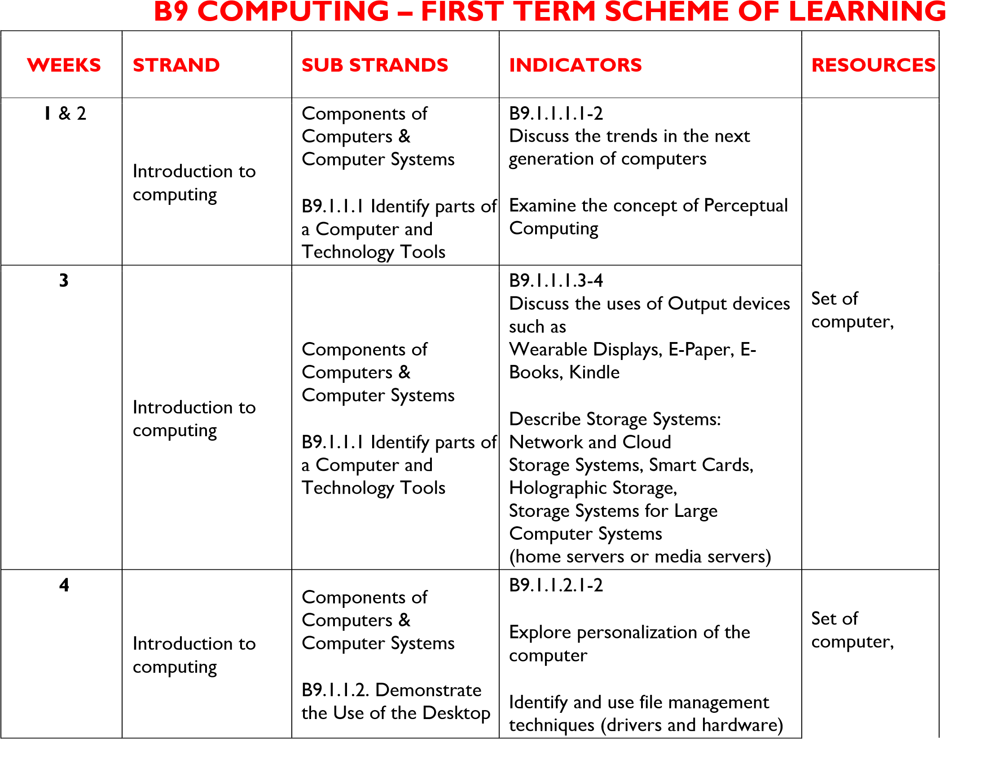

|  |  |  |  |  |
| --- | --- | --- | --- | --- |
| **5** | Productivity  Software | Introduction to Word  Processing    B9.2.1.1 Demonstrate  How to Use Microsoft  Word (Multimedia) | B9.2.1.1.1  Demonstrate how to add pictures, insert a screenshot and screen clipping and print screen |  |
| **6** | Productivity  Software | Introduction to Word  Processing    B9.2.1.1 Demonstrate  How to Use Microsoft  Word (Multimedia) | B9.2.1.1.2  Demonstrate the use of  SmartArt | Set computer,  Video /pictures |
| **7** | Productivity  Software | Introduction to Word  Processing    B9.2.1.1 Demonstrate  How to Use Microsoft  Word (Multimedia) | B9.2.1.1.3  Demonstrate how to add Multimedia (audios, videos, animations), Charts and  Hyperlinks |

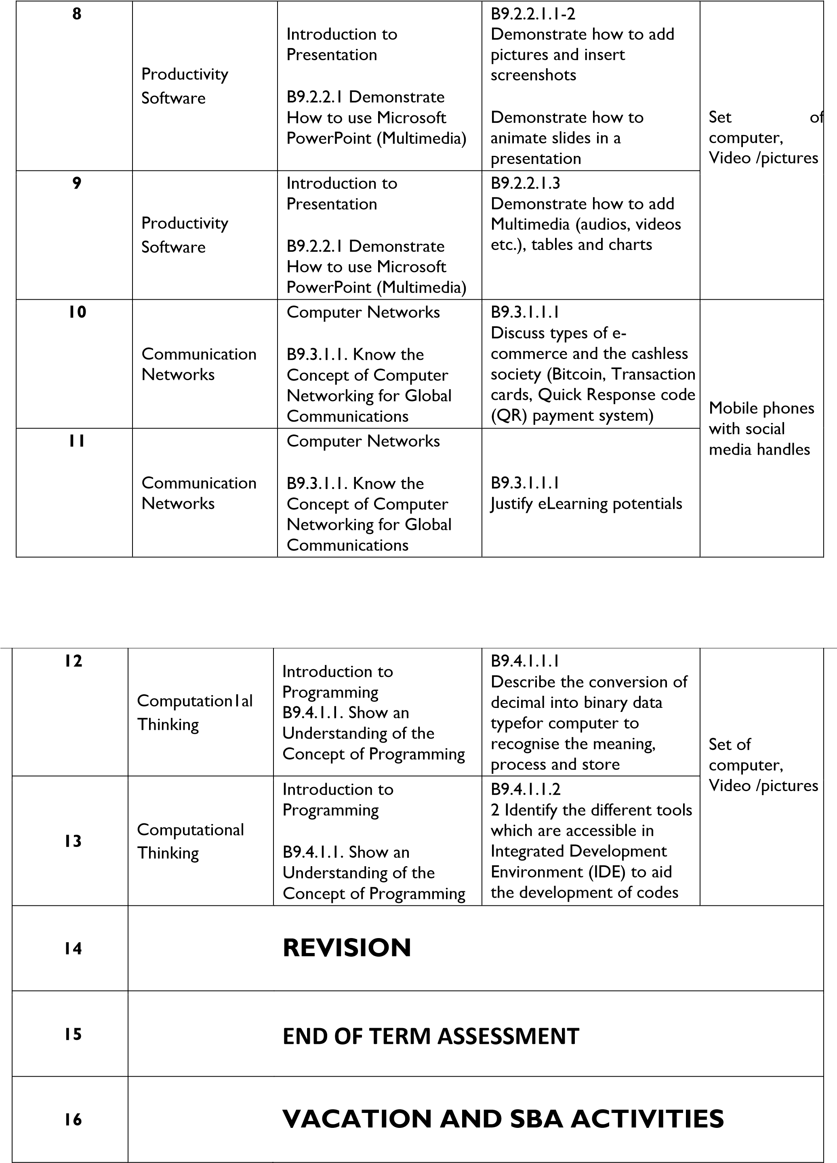

**B9 SCIENCE – FIRST TERM SCHEME OF LEARNING**

|  |  |  |  |  |
| --- | --- | --- | --- | --- |
| **WEEKS** | **STRAND** | **SUB STRAND** | **INDICATORS** | **RESOURCES** |
| **1&2** | Diversity of Matter | Materials B9.1.1.1 Show an understanding of formation of binary chemical compounds and their uses (Acids, Bases and Salts) | B9.1.1.1.1-2  Identify by name binary chemical compounds and discuss their uses.    Discuss the formation of binary chemical compounds. | Charts & Pictures |
| **3** | Diversity of Matter | Materials  B9.1.1.2 Demonstrate knowledge of atomic bonding in the formation of chemical compounds | B9.1.1.1.3  Describe the characteristics of common acids, bases and salts.    B9.1.1.2.1  Recognise that chemical bond results from the attraction between atoms in a compound | Charts & Pictures |
| **4** | Diversity of Matter | Living Cells  B9.1.2.1 Demonstrate knowledge of specialist cells of dicotyledonous plants and humans, their formation and functions for  the existence of the plants and humans | B9.1.2.1.1-2  Discuss the concepts of specialised cells and how they are formed in dicotyledonous plants and humans    Examine the functions of specialised cells in dicotyledonous plants such as epidermal, guard cells, | Charts & Pictures |
|  |  |  | cambium, xylem in relation to the existence of the plants |  |
| **5** | Diversity of Matter | Living Cells  B9.1.2.1 Demonstrate knowledge of specialist cells of dicotyledonous plants and humans, their formation and functions for  the existence of the plants and humans | B9.1.2.1.3  Examine the functions of specialised animal cells such as (nerve, blood cells, muscle cells and sperm cells) in relation to the existence of humans | Charts & Pictures |
| **6** | Cycles | Earth science  B9.2.1.1 Demonstrate an understanding of the Nitrogen cycle as a repeated pattern of change in nature, and how it relates to the environment | B9.2.1.1.1-2  Explain the process of the nitrogen cycle as a repeated pattern in nature    Describe the importance of the  nitrogen cycle to the environment | Charts & Pictures |
| **7** | Cycles | Life cycles of organisms B9.2.2.1 Demonstrate an understanding of the life cycle of grasshopper and assess how their activities affect humans | B9.2.2.1.1-2  Describe the life cycle of the grasshopper as a form of  incomplete metamorphosis    Examine how the activities of the grasshopper affect humans | Charts & Pictures |
| **8** | Systems | Human Body systems B9.3.1.1 Demonstrate understanding of the blood circulatory system, health problems associated with the system and its relationship with the  respiratory system in humans | B9.3.1.1.1  Explain the concept of the circulatory system, state the function of each part of the system and the health challenges associated with it | Charts & Pictures |
| **9** | Systems | Human Body systems B9.3.1.1 Demonstrate understanding of the blood circulatory system, health problems associated with the system and its relationship with the  respiratory system in humans | B9.3.1.1.2  Explain the concept of respiration and show how the respiratory and circulatory systems complement each other. (Note that respiration is a chemical reaction that releases carbon dioxide (CO2), water (H2O) and energy from glucose and oxygen). | Charts & Pictures |
| **10** | Forces & Energy | Energy B9.4.1.1 Show understanding of the concept of conservation of energy and ways of conserving energy | B9.4.1.1.1-2  List the ways to conserve energy. Examples: ironing in bulk, using energy efficient appliances and switching off appliances when not in use.    Explain the importance of energy conservation in daily life.    B9.4.1.2.1 | Charts & Pictures |
|  |  |  | Explain how to calculate energy consumed over a period of time |  |
| **11** | Forces & Energy | Energy  B9.4.1.2 Demonstrate understanding in and the capability to do calculations involving energy. | B9.4.1.2.2-4  Describe how images are formed in cameras.    Describe the formation of shadows.    Demonstrate the formation of an eclipse. | Charts & Pictures. |
| **12** | Forces & Energy | Energy  B9.4.1.3 Evaluate the application of light energy in life. | B9.4.1.3.1  Demonstrate that light changes path when it travels from one medium to a different medium. | Charts & Pictures. |
| **13** | Forces & Energy | Energy  B9.4.1.3 Evaluate the application of light energy in life. | B9.4.1.3.1  Demonstrate that light changes path when it travels from one medium to a different medium. | Charts & Pictures. |
| **14** |  | REVISION | |  |
| **15** |  | END OF TERM ASSESSMENT | |  |
| **16** |  | VACATION AND SBA ACTIVITIES | |  |

**GH. LANG**

**SCHEME OF LEARNING – TERM 1 B9**

|  |  |  |  |  |
| --- | --- | --- | --- | --- |
| **WEEKS** | **STRAND** | **SUB STRANDS** | **INDICATORS** | **RESOURCES** |
| 1 & 2 | Customs &  Institutions | Marriage Rites | B9.1.1.1.1 | Word cards, |
|  |  |  |
|  | Listening & Speaking | Conversation | B9.2.1.1.1 | sentence cards, letter cards |
| Reading | Reading | B9.3.1.1.1 |
| 3 |  |  |  |  |
|  | Language & Usage | Nouns | B9.4.2.1.1 | Word cards, |
|  |  |  |
|  | Composition Writing | Narrative Writing | B9.5.1.1.1 | sentence cards, letter cards |
| Literature | Literature | B9.6.1.1.1 |
| 4 | Customs &  Institutions | Marriage Rites | B9.1.1.1.1 | Word cards, |
|  |  |  |
|  | Listening & Speaking | Conversation | B9.2.1.1.1 | sentence cards, letter cards, and a class library |
| Reading | Reading | B9.3.1.1.1 |
| 5 |  |  |  |  |
|  | Language & Usage | Nouns | B9.4.2.1.1 | Word cards, |
|  |  |  |
|  | Composition Writing | Narrative Writing | B9.5.1.1.1 | sentence cards, letter cards, and a class library |
| Literature | Literature | B9.6.1.1.1 |
| 6 | Customs &  Institutions | Marriage Rites | B9.1.1.1.2 | Word cards, |
|  |  |  |
|  | Listening & Speaking | Conversation | B9.2.1.1.2 | sentence cards, letter cards, and a class library |
| Reading | Translation | B9.3.2.1.1 |
| 7 |  |  |  |  |
|  | Language & Usage | Adjectives | B9.4.2.2.1 | Word cards, |
|  |  |  |
|  | Composition Writing | Descriptive Writing | B9.5.1.1.1 | sentence cards, letter cards, and a class library |
| Literature | Literature | B9.6.1.1.1 |
| 8 | Customs &  Institutions | Marriage Rites | B9.1.1.1.2 | Word cards, |
|  |  |  |
|  | Listening & Speaking | Conversation | B9.2.1.1.2 | sentence cards, letter cards, and a class library |
| Reading | Translation | B9.3.2.1.1 |
| 9 |  |  |  |  |
|  | Language & Usage | Adjectives | B9.4.2.2.1 | Word cards, |
|  |  |  |
|  | Composition Writing | Descriptive Writing | B9.5.1.1.1 | sentence cards, letter cards, and a class library |
| Literature | Literature | B9.6.1.1.1 |
| 10 | Customs &  Institutions | Marriage Rites | B9.1.1.1.3 | Word cards, |
|  |  |  |
|  | Listening & Speaking | Conversation | B9.2.1.1.3 | sentence cards, letter cards, and a class library |
| Reading | Reading | B9.3.1.1.2 |
| 11 |  |  |  |  |
|  | Language & Usage | Adjectives | B9.4.2.2.1 | Word cards, |
|  |  |  |
|  | Composition Writing | Creative Writing | B9.5.1.1.1 | sentence cards, letter cards, and a class library. |
| Reading | Translation | B9.3.2.1.1 |
| 12 | Customs &  Institutions | Marriage Rites | B9.1.1.1.3 | Word cards, sentence cards, |
|  |  |  |
|  | Listening & Speaking | Conversation | B9.2.1.1.3 | letter cards, and a class library. |
| Reading | Reading | B9.3.1.1.2 |
| 13 | Customs &  Institutions | Marriage Rites | B9.1.1.1.3 |  |
| Listening & Speaking | Conversation | B9.2.1.1.3 |
| Reading | Reading | B9.3.1.1.2 |
| 14 | **REVISION** | | | |
| 15 | **END OF TERM ASSESSMENT AND VACATION** | | | |
| 16 | **VACATION AND SBA ACTIVITIES** | | | |

**FRENCH – BASIC 9**

|  |  |  |  |
| --- | --- | --- | --- |
| **WEEK** | **STRANDS** | **SUB-STRANDS** | **CONTENT** |
|  | L’environnement | Parler de la protection de l’environnement | **STANDARD** |
| **1&2** | B9.2.5.1 |
| **3** | L’environnement | Parler de la protection de l’environnement | B9.2.5.1 |
| **4** | Les achats | Passer une commande | B9.5.5.1 |
| **5** | Les achats | Passer une commande | B9.5.5.1 |
| **6** | Les achats | Passer une commande | B9.5.5.1 |
| **7** | Les loisirs | Parler dutourisme | B9.6.4.1 |
| **8** | Les loisirs | Parler dutourisme | B9.6.4.1 |
| **9** | Les habitudes et les faits du passe | Parler des événements du passe | B9.7.1.1 |
| **10** | Les habitudes et les faits du passe | Parler des événements du passe | B9.7.1.1 |
| **11** | Les habitudes et les faits du passé | Rapporter un fait | B9.7.2.1 |
| **12** | : Les habitudes et les faits du passé | Rapporter un fait | B9.7.2.1 |
| **13** | : Les habitudes et les faits du passé | Rapporter un fait | B9.7.2.1 |
| **14** | **REVISION** |  |  |
| **15** | **ASSESSMENT** |  |  |
| **16** | **VACATION** |  |  |

**B9 CAREER TECH TERM 1 SCHEME**

|  |  |  |  |  |
| --- | --- | --- | --- | --- |
| **WEEKS** | **STRAND** | **SUB STRANDS / CS** | **INDICATORS** | **RESOURCES** |
| **1&2** | Health and Safety | Personal Hygiene & Food Hygiene    B9.1.1.1 Demonstrate skills that relate to personal and food hygiene to self | B9.1.1.1.1-2  Practice good grooming    Observe appropriate food hygiene practices. | Pictures, Posters and illustrations |
| **3** | Health and Safety | Workshop And Food Laboratory  Safety    B9.1.2.1 Demonstrate skills that relate to personal, workshop and laboratory safety | B9.1.2.1.1-2  Describe procedures for reporting accidents and unsafe practices in school and in the laboratory/workshop/site    Use appropriate personal protective equipment when working |
| **4** | Materials for Production | Workshop And Food Laboratory Safety    B9.1.2.1 Demonstrate skills that relate to personal, workshop and laboratory safety | B9.1.2.1.3:  Maintain safe working environments | Pictures, Posters and illustrations |
| **5** | Materials for Production | Environmental Health    B9.1.3.1 Demonstrate understanding and practice of environmental health in the school/home | B9.1.3.1.1: Discuss the causes and prevention of poor  sanitation in the school/home/  community/workshop/site/lab oratory. |
| **6** | Materials for Production | Environmental Health    B9.1.3.2 Demonstrate understanding of  clean energy, and Improved Cookstoves (ICS) and their accompanying fuels | B9.1.3.2.1-2  Discuss what is meant by clean energy and improved cookstoves and fuels.    Discuss the benefits of  improved cookstoves and  fuels | Pictures, Posters and illustrations |
| **7** | Tools,  Equipment &  Processes | Compliant Materials    B9.2.1.1 Demonstrate skills in selecting compliant materials for making products and artefacts | B9.2.1.1.1: Discuss the factors that influence the selection of compliant materials |
| **8** | Tools,  Equipment &  Processes | Resistant Materials    B9.2.2.1 Demonstrate skills in selecting resistant materials for making products/artefacts | B9.2.2.1.1-2:  Discuss the factors that influence the selection of resistant materials    Discuss the reasons why resistant materials require particular techniques and tools for their safe handling |  |
|  |  |  | and use | Pictures, Posters and illustrations |
| **9** | Technology | Smart And Modern Materials    B9.2.3.1 Demonstrate understanding of using smart and modern materials for making products/artefacts | B9.2.3.1.1-2:  Discuss reasons for using smart and modern materials  for making products/artefacts    Demonstrate techniques for making prototypes/ projects to solve problems in the environment using smart and modern materials |
| **10** | Technology | Food Commodities    B9.2.4.1 Demonstrate skills in selecting food commodities in meal preparation | B9.2.4.1.1-2:  Discuss how to select food commodities used for meal preparation    Discuss the basic food |  |
|  |  |  | requirements for different members of the family | Pictures, Posters and illustrations |
| **11** | Designing &  Making of  Artefacts | Measuring & Marking Out    B9.3.1.1 Demonstrate understanding of measuring and marking out tools and equipment | B9.3.1.1.1  Discuss tools and equipment used for measuring and marking out |
| **12** | Designing &  Making of  Artefacts | Measuring & Marking Out    B9.3.1.1 Demonstrate understanding of measuring and marking out tools and equipment | B9.3.1.1.2  Demonstrate how to use the tools and equipment for measuring and marking out | Pictures, Posters and illustrations |
| **13** | Designing &  Making of  Artefacts | Cutting/Shaping    B9.3.2.1 Demonstrate the  understanding of cutting/shaping tools | B9.3.2.1.1-2:  Discuss tools and equipment  used for cutting and shaping |
|  |  | and equipment used for making artefacts/ products | Demonstrate how to use shaping and cutting tools and equipment for producing artefacts/products |  |
| **14** | END OF TERM ASSESSMENT | | | |
| **15** | VACATION AND SBA ACTIVITIES | | | |
| **16** |  | | | |